|  |  |  |  |  |  |  |  |  |  |  |  |  |  |
| --- | --- | --- | --- | --- | --- | --- | --- | --- | --- | --- | --- | --- | --- |
| **Ejercicios Nivel 0** | | | | | | | | | | | | | |
| **N0_L3_E1** | | **N0_L4_E1** | | **N0_L4_E2** | | **N0_L4_E3** | | **N0_L8_E1** | | **N0_L8_E2** | | **N0_L8_E3** | |
| **2** | **1.99** | **5** | **2.12** | **2** | **2.10** | **1** | **1.91** | **2** | **1.88** | **3** | **2.39** | **1** | **1.89** |

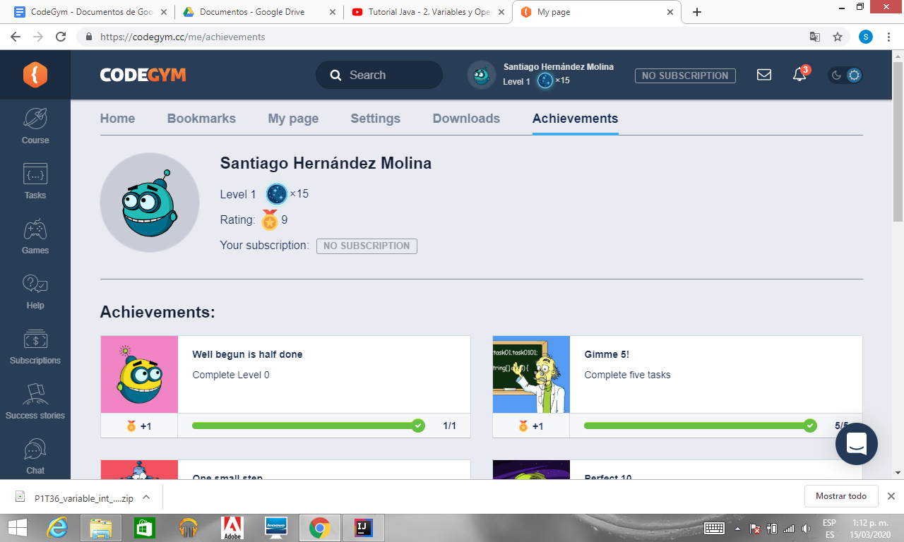

**N0_L3_E1**

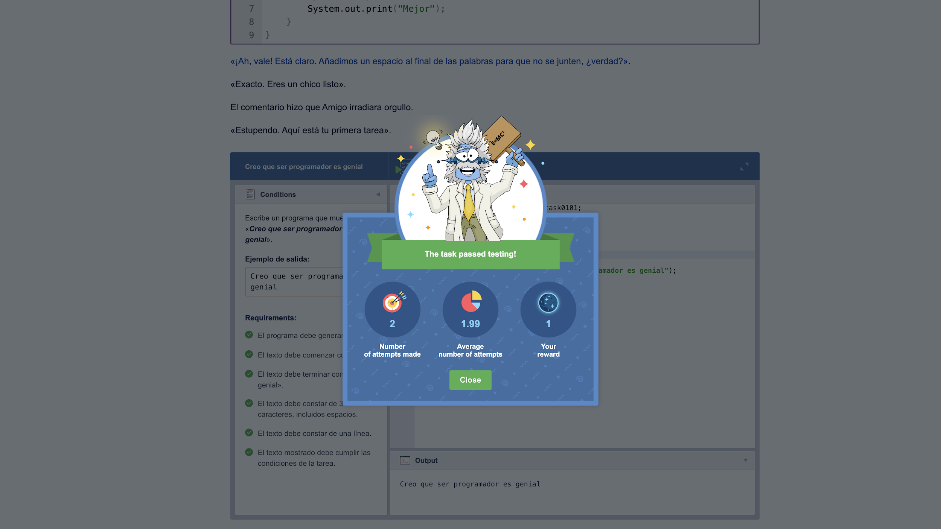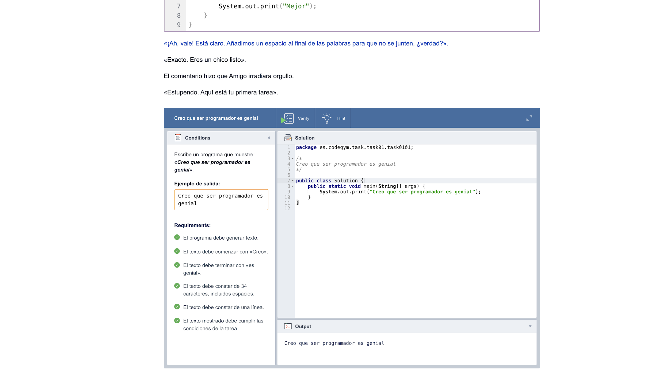

**N0_L4_E1**

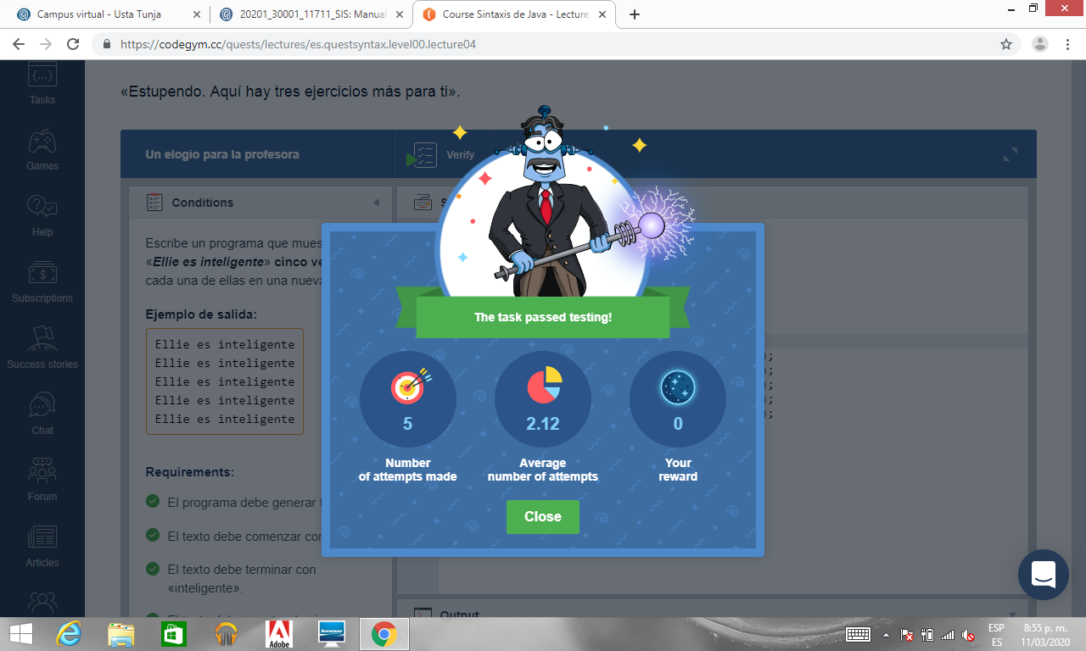

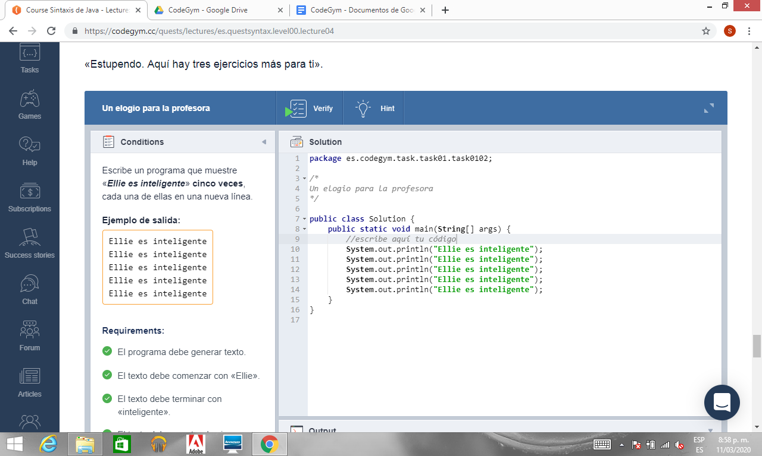

**N0_L4_E2**

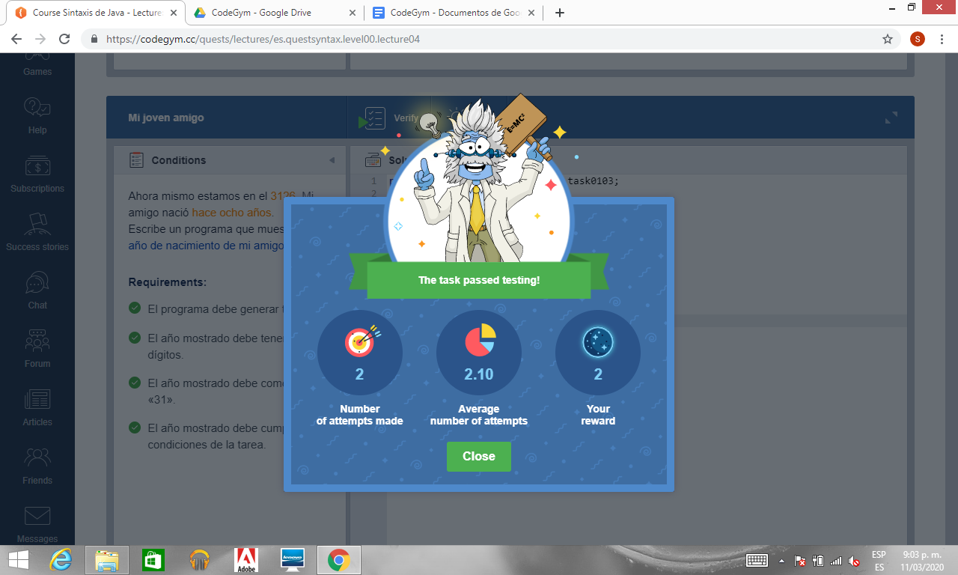

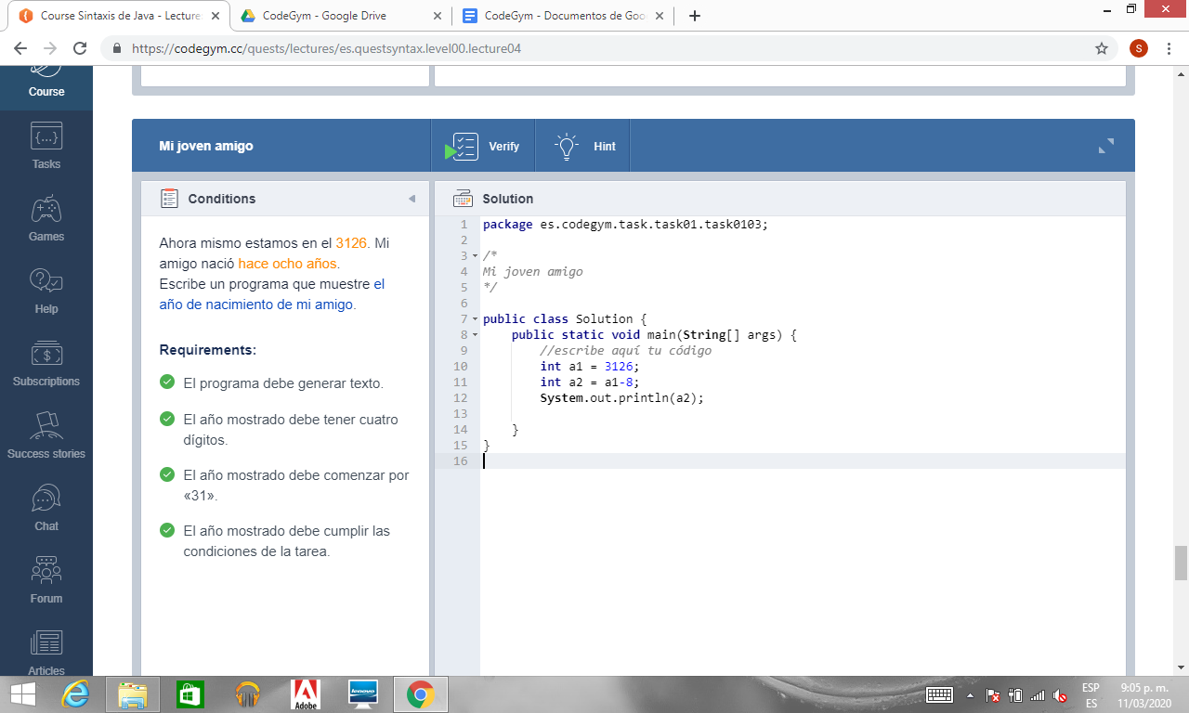

**N0_L4_E3**

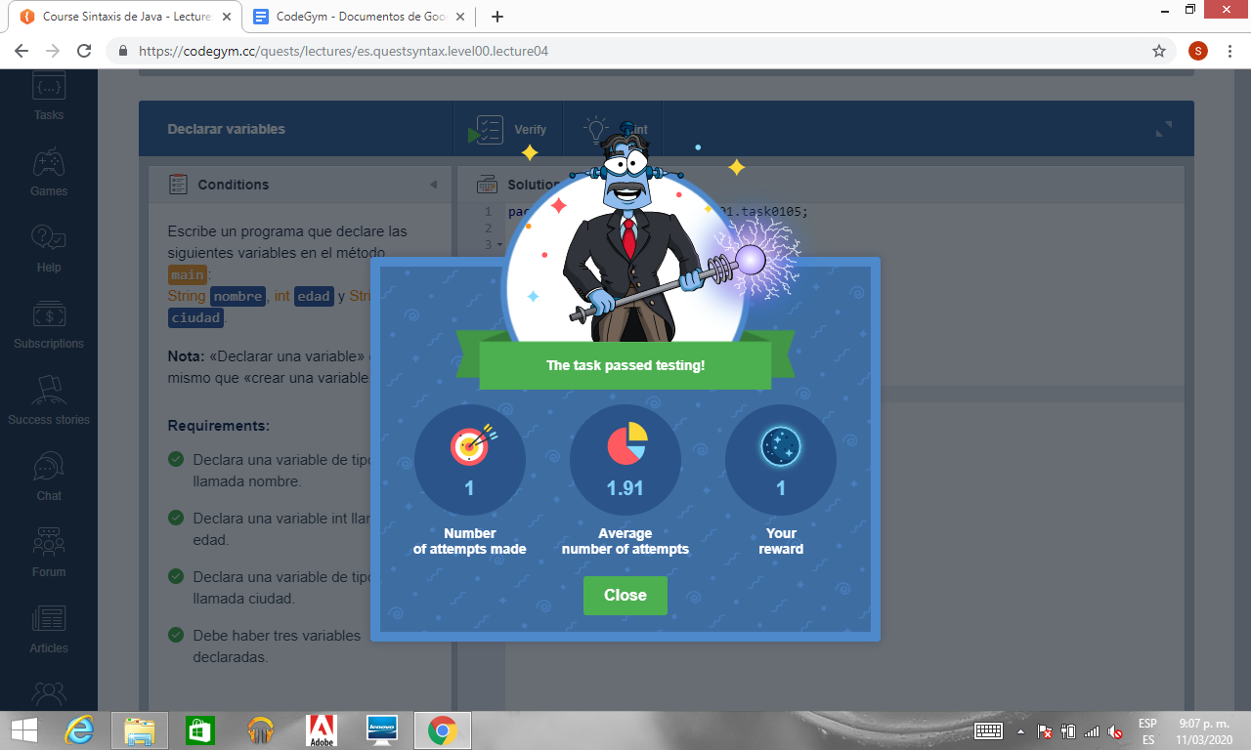

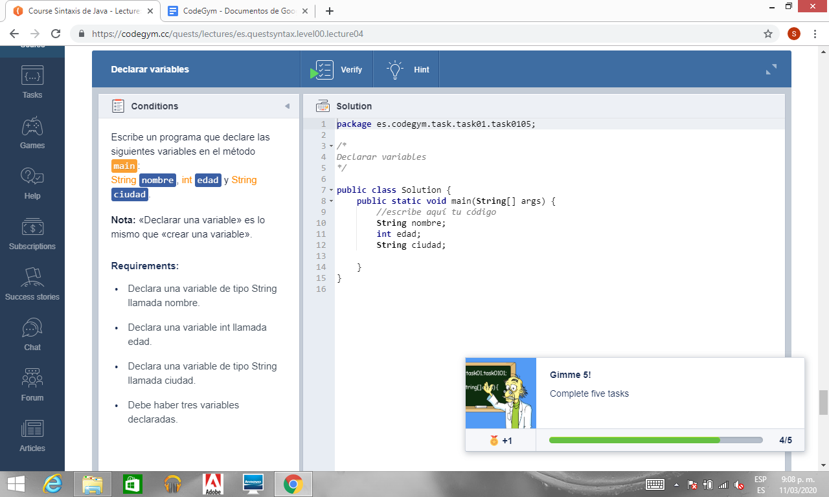

**N0_L8_E1**

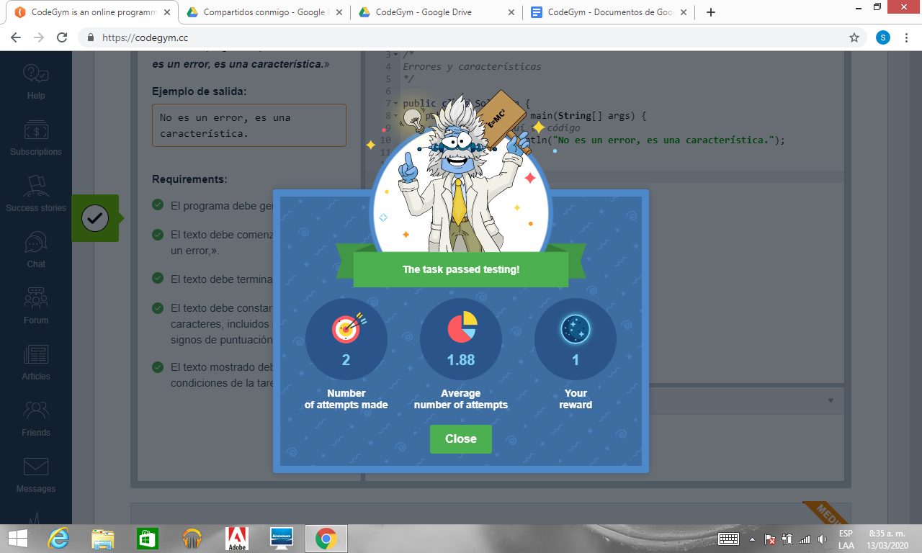

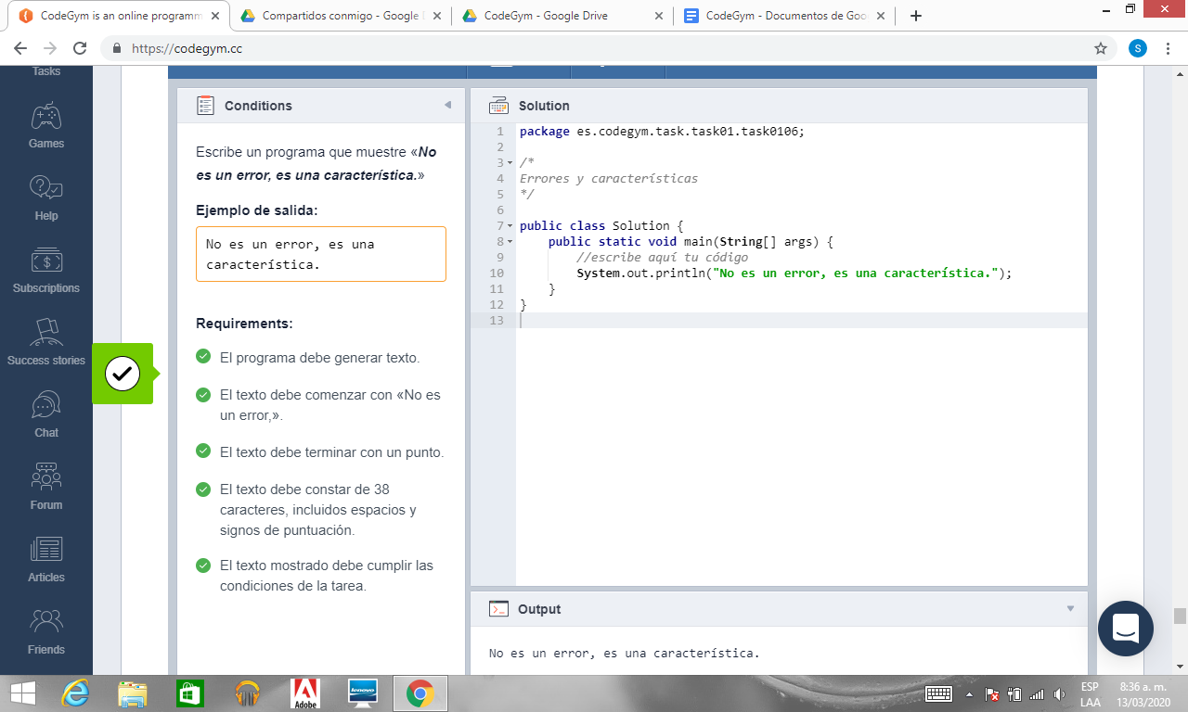

**N0_L8_E2**

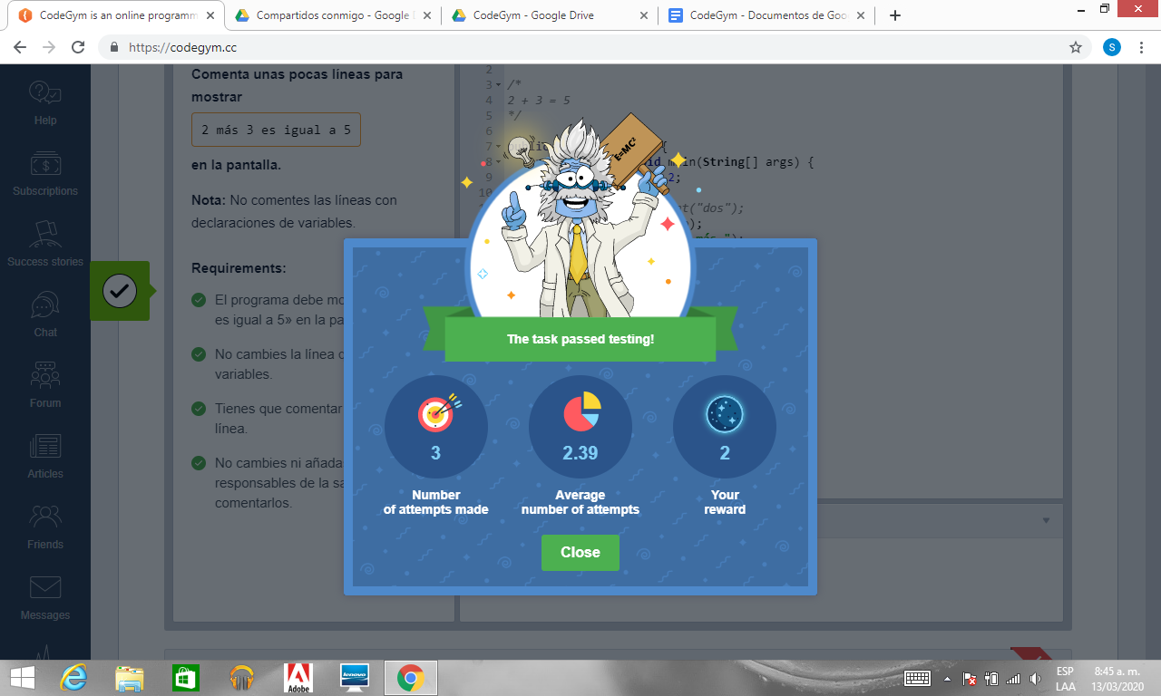

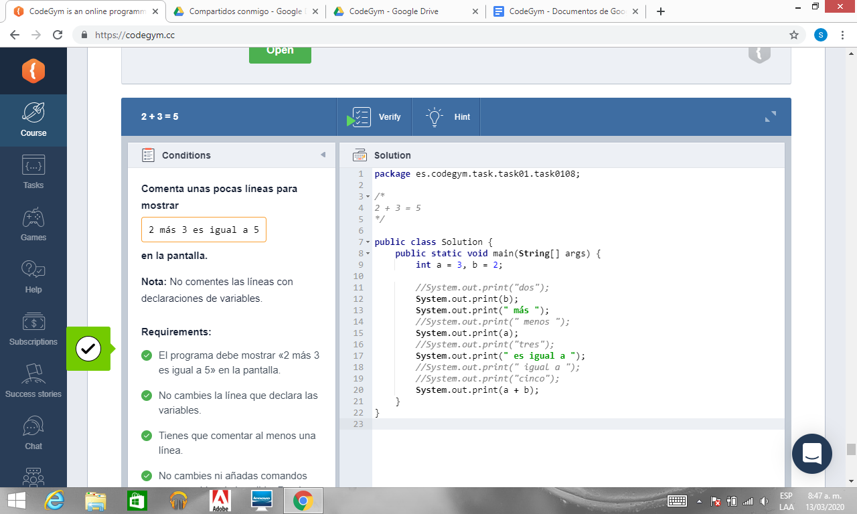

**N0_L8_E3**

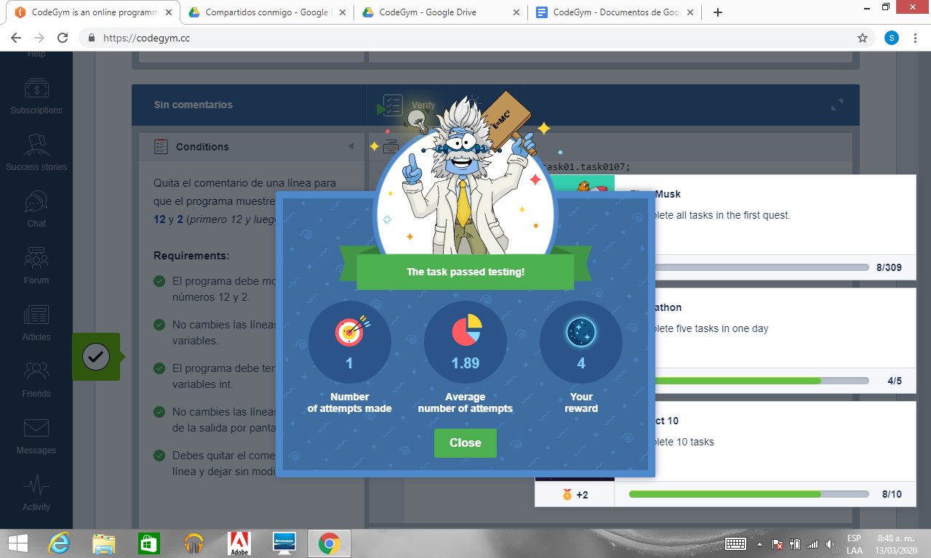

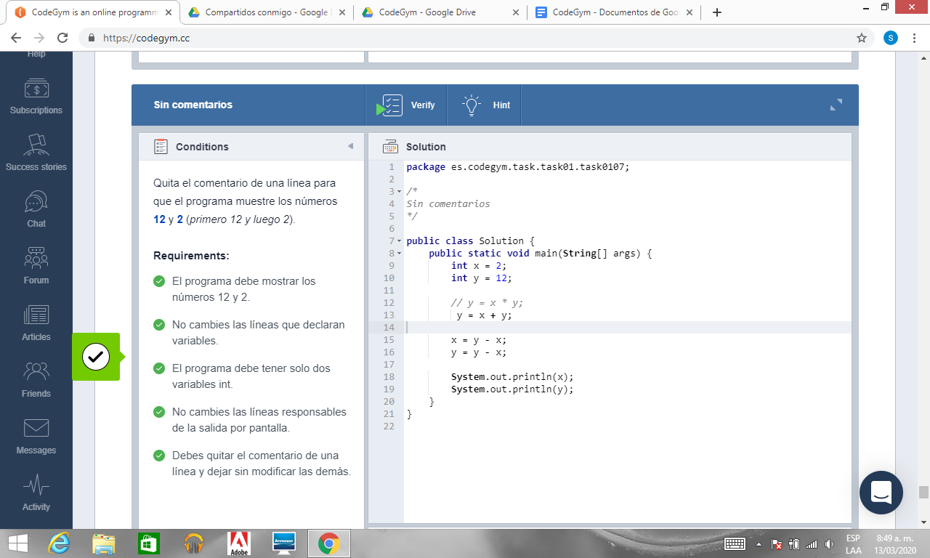

**Achievements**

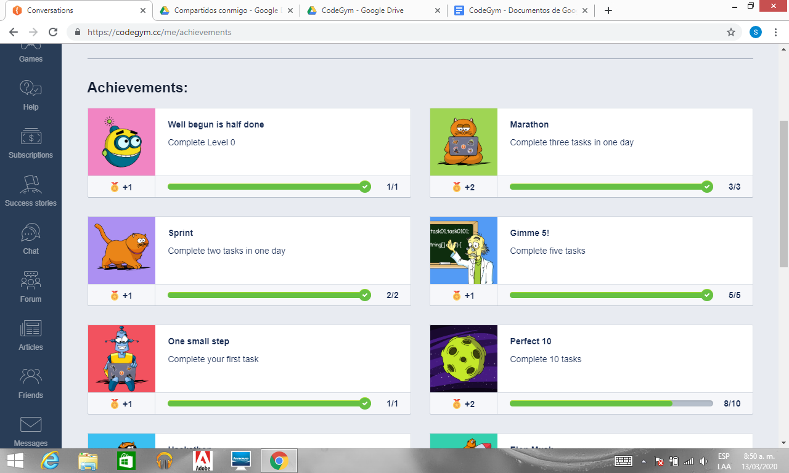

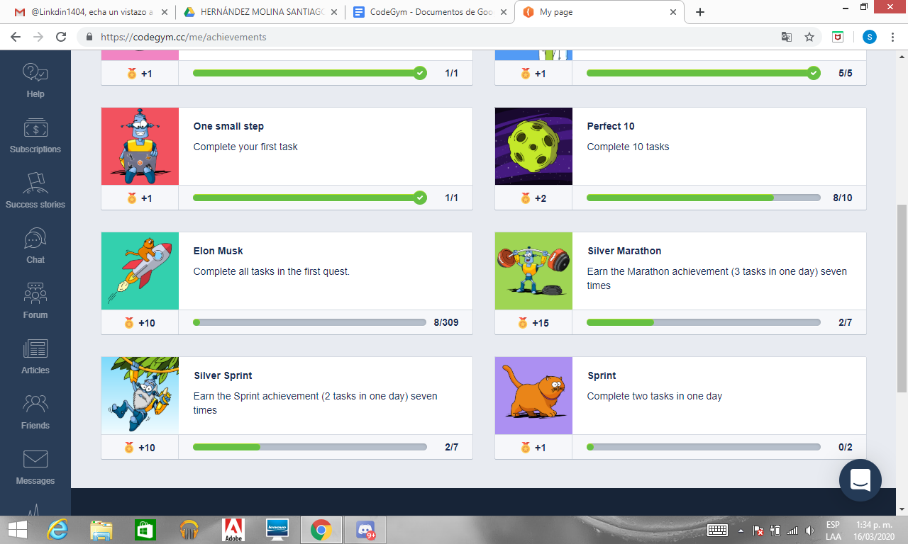

|  |  |  |  |  |  |  |  |  |  |  |  |  |  |
| --- | --- | --- | --- | --- | --- | --- | --- | --- | --- | --- | --- | --- | --- |
| **Ejercicios Nivel 1** | | | | | | | | | | | | | |
| **N1_L3_E1** | | **N1_L3_E2** | | **N1_L3_E3** | | **N1_L3_E4** | | **N1_L4_E1** | | **N1_L4_E2** | | **N1_L4_E3** | |
| **1** | **1.35** | **13** | **2.25** | **1** | **1.54** | **3** | **2.23** | **1** | **2.40** | **3** | **2.62** | **1** | **1.92** |

|  |  |  |  |  |  |  |  |  |  |  |  |  |
| --- | --- | --- | --- | --- | --- | --- | --- | --- | --- | --- | --- | --- |
| **Ejercicios Nivel 1** | | | | | | | | | | | | |
| **N1_L4_E4** | | **N1_L4_E5** | | **N1_L4_E6** | | **N1_L4_E7** | | **N1_L5_E1** | | **N1_L6_E1** | | **N1_L7_E1** |
| **1** | **1.24** | **3** | **1.07** | **2** |  | **1** |  | **2** | **1.70** | **2** | **3.96** | **haven´t** |

|  |  |  |  |  |  |  |  |  |  |  |  |  |  |
| --- | --- | --- | --- | --- | --- | --- | --- | --- | --- | --- | --- | --- | --- |
| **Ejercicios Nivel 1** | | | | | | | | | | | | | |
| **N1_L7_E2** | | **N1_L7_E3** | | **N1_L8_E1** | | **N1_L8_E2** | | **N1_L8_E3** | | **N1_L8_E4** | | **N1_L8_E5** | |
| **1** | **1.09** | **4** | **2.64** | **1** | **2.19** | **2** | **1.47** | **4** | **3.17** | **4** | **1.89** | **1** | **4.59** |

|  |  |
| --- | --- |
| **Ejercicios Nivel 1** | |
| **N1_L8_E6** | |
| **3** | **3.01** |

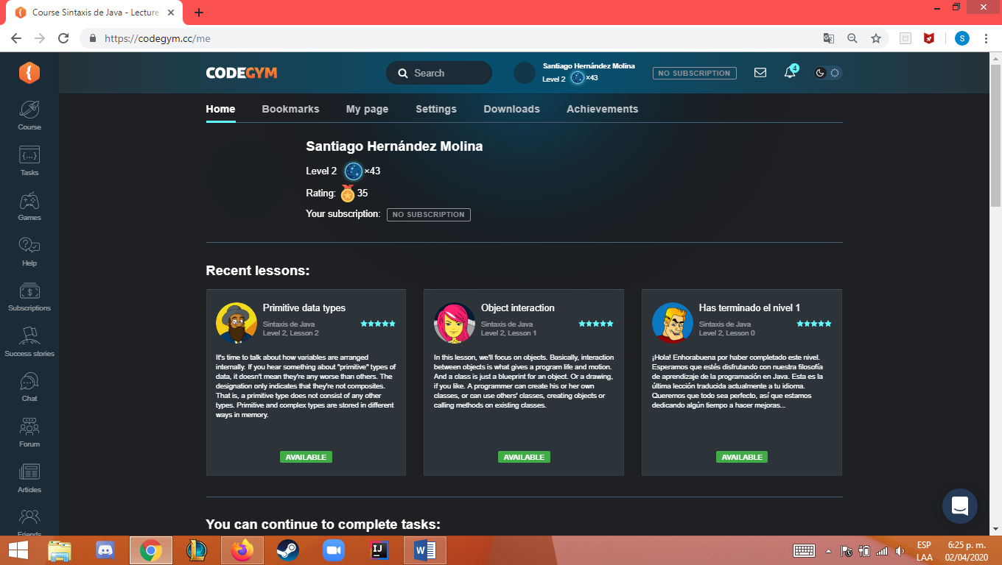

**N1_L3_E1**



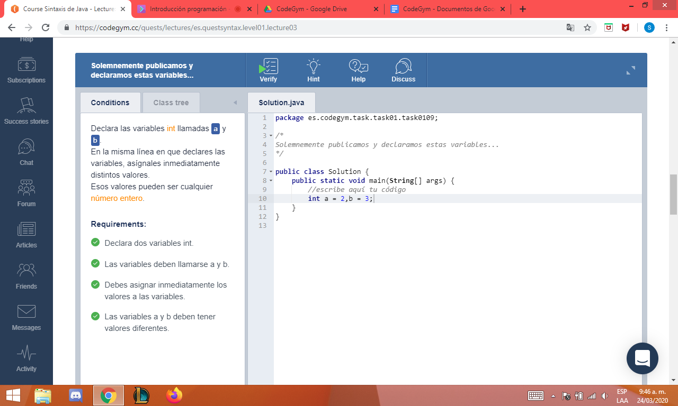

**N1_L3_E2**

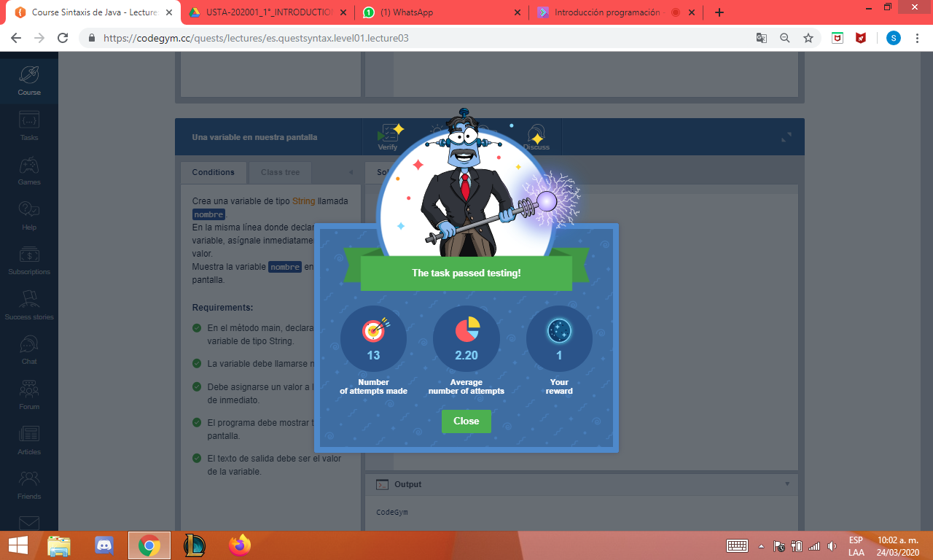

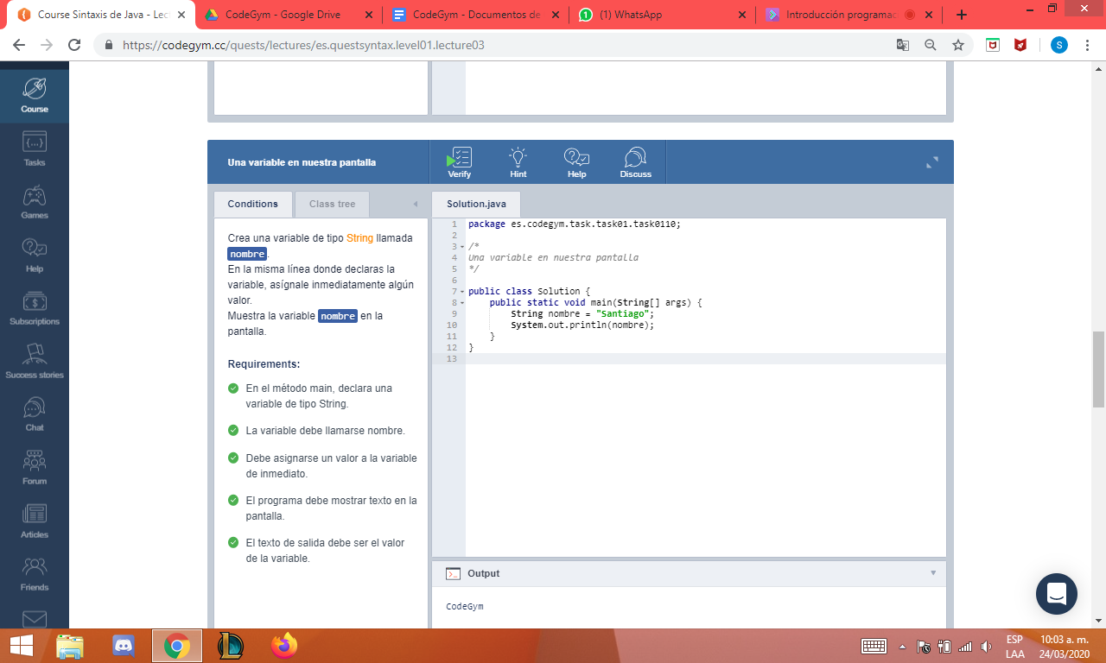

**N1_L3_E3**

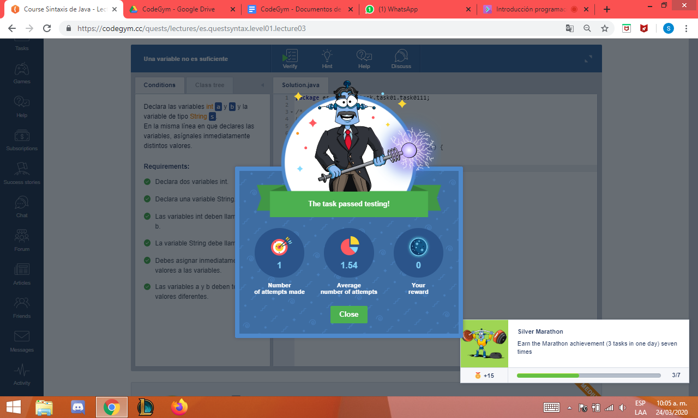

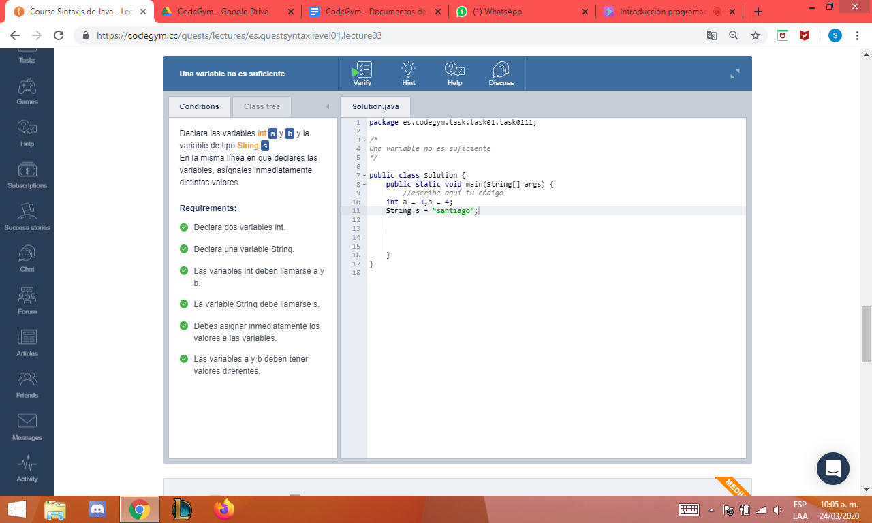

**N1_L3_E4**

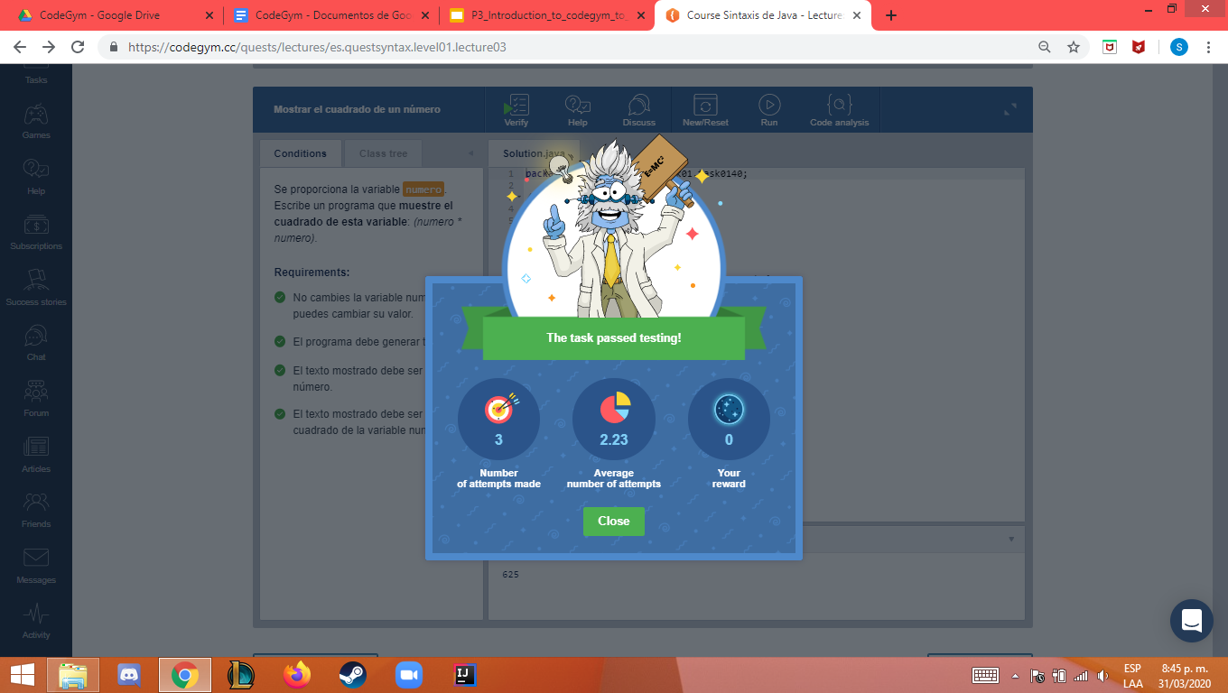

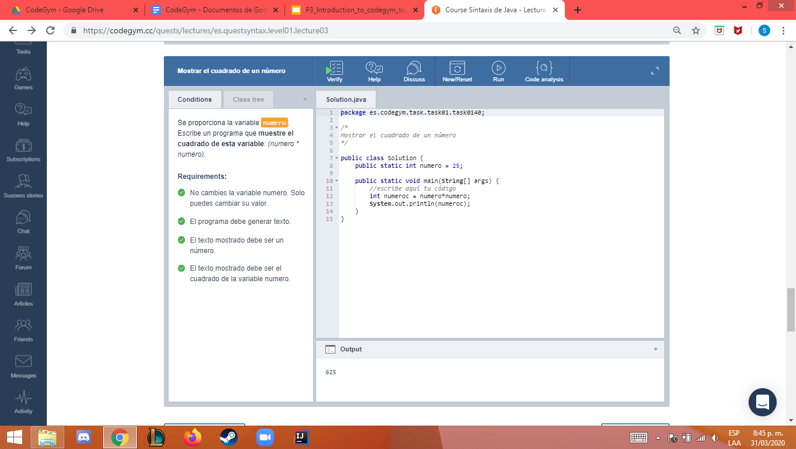

**N1_L4_E1**

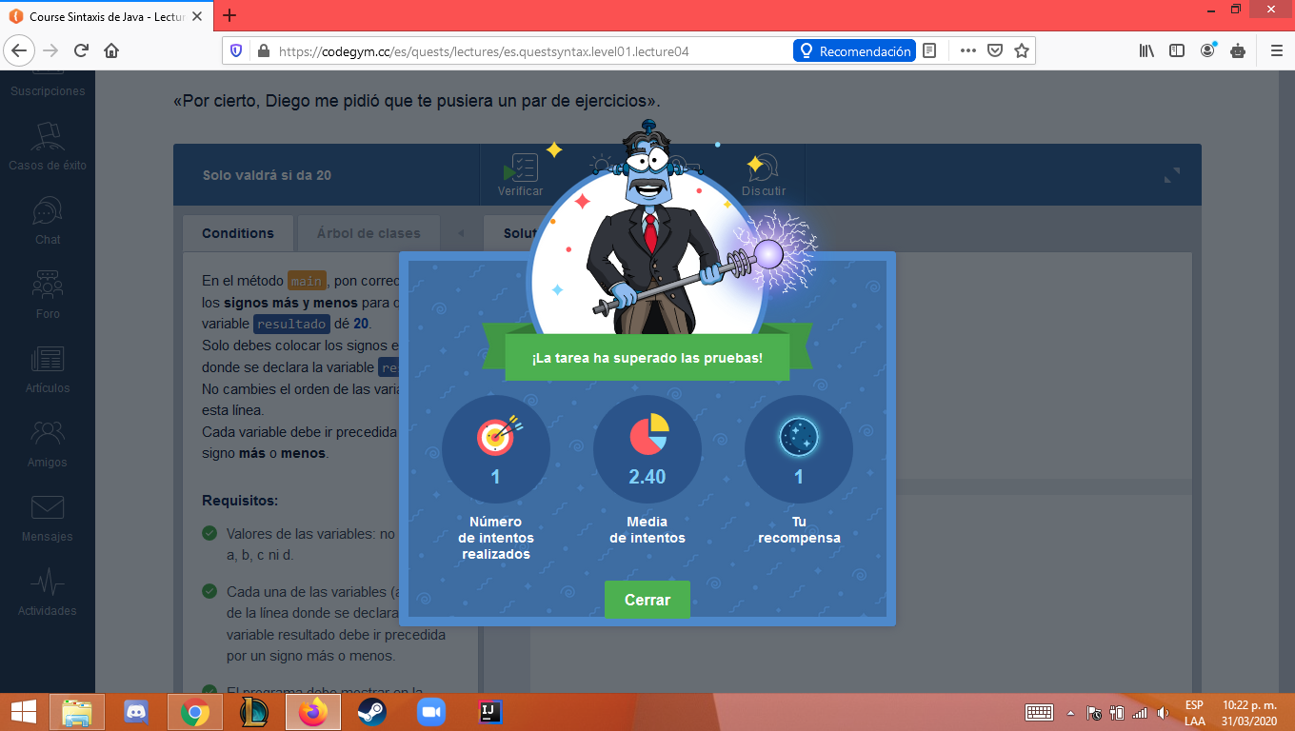

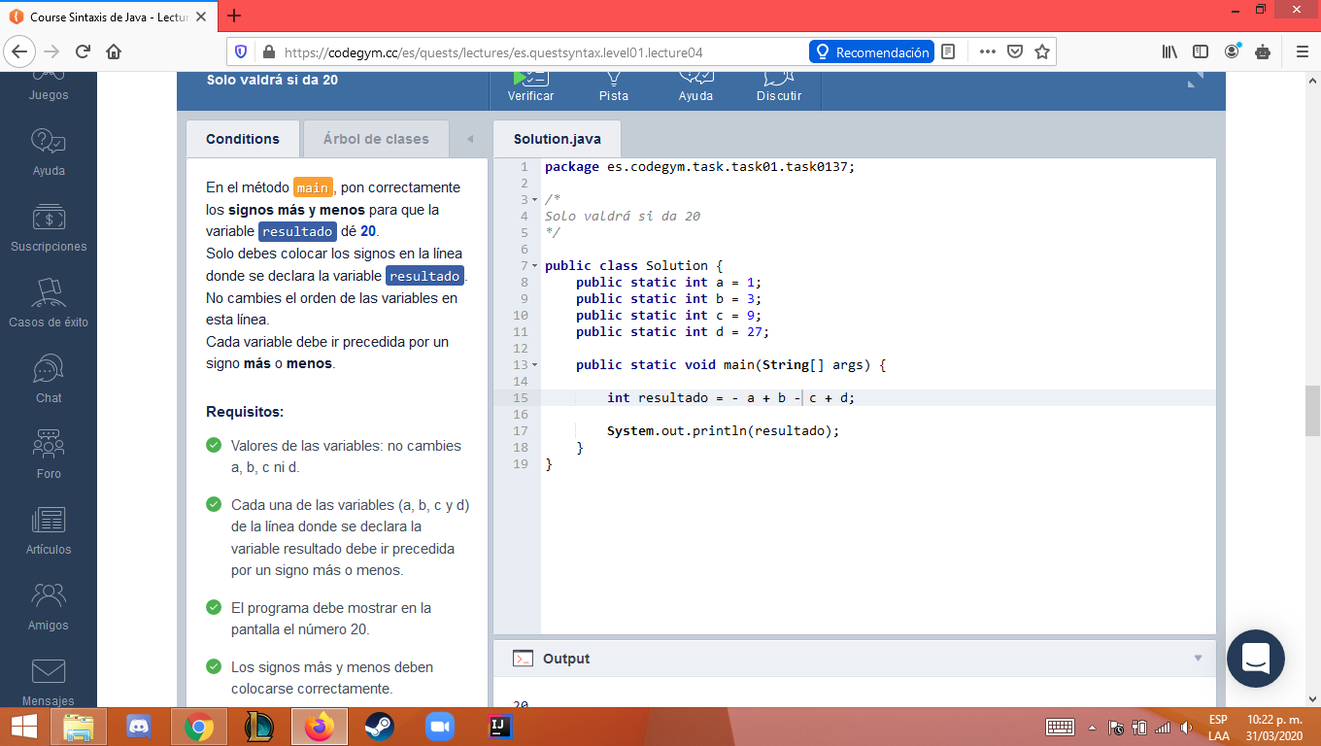

**N1_L4_E2**

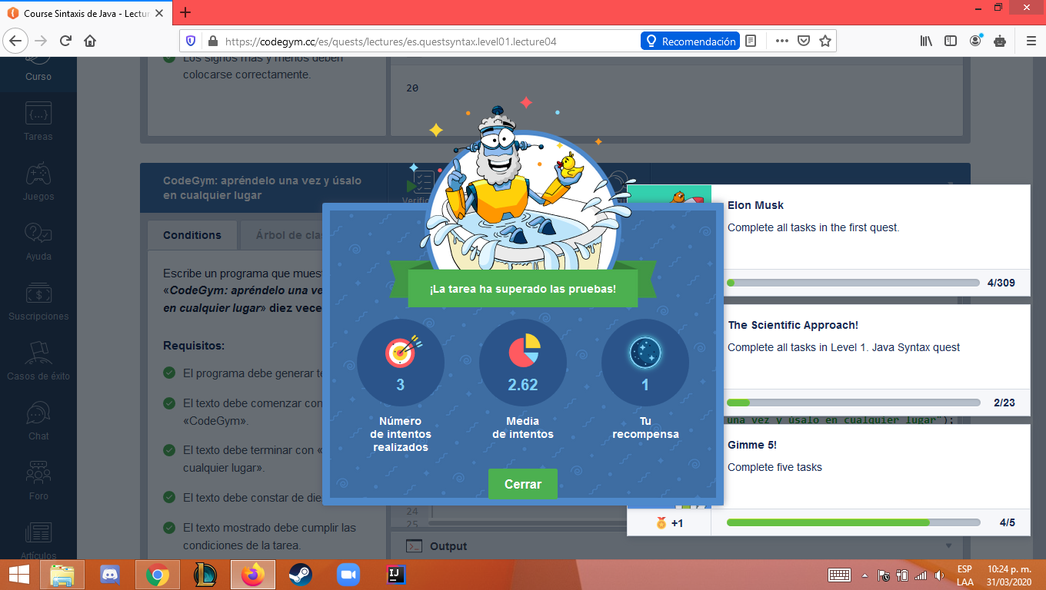

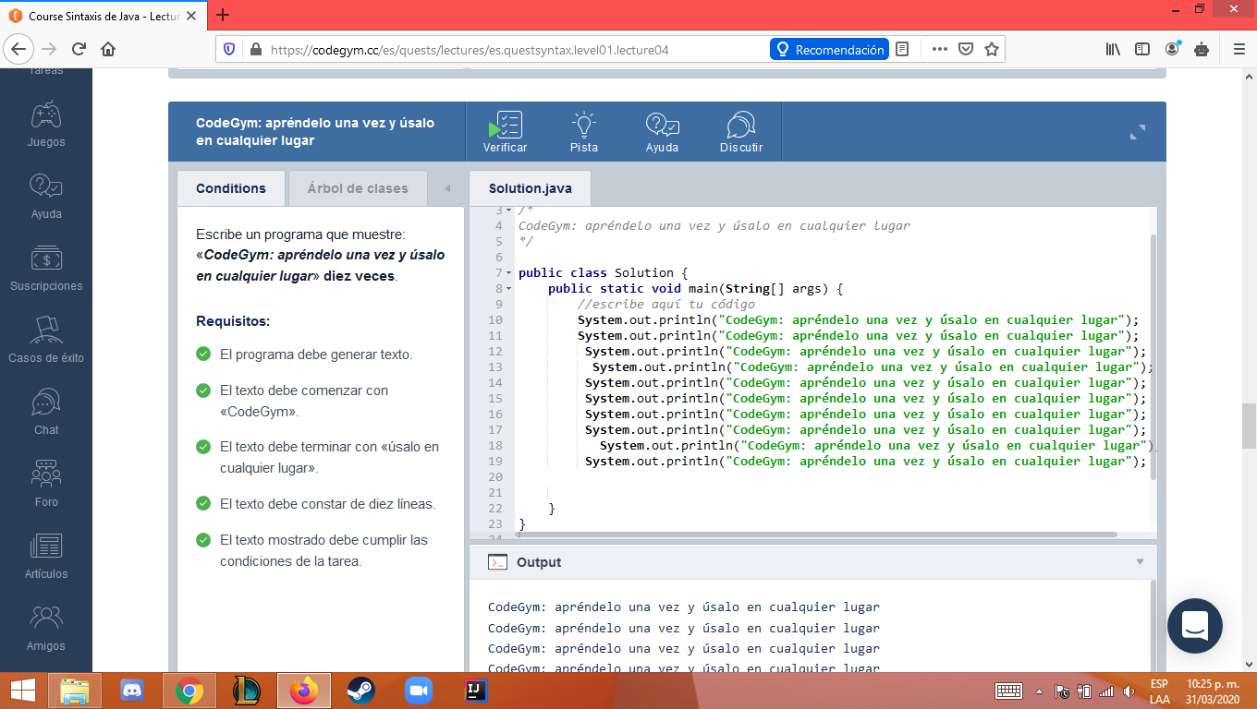

**N1_L4_E3**

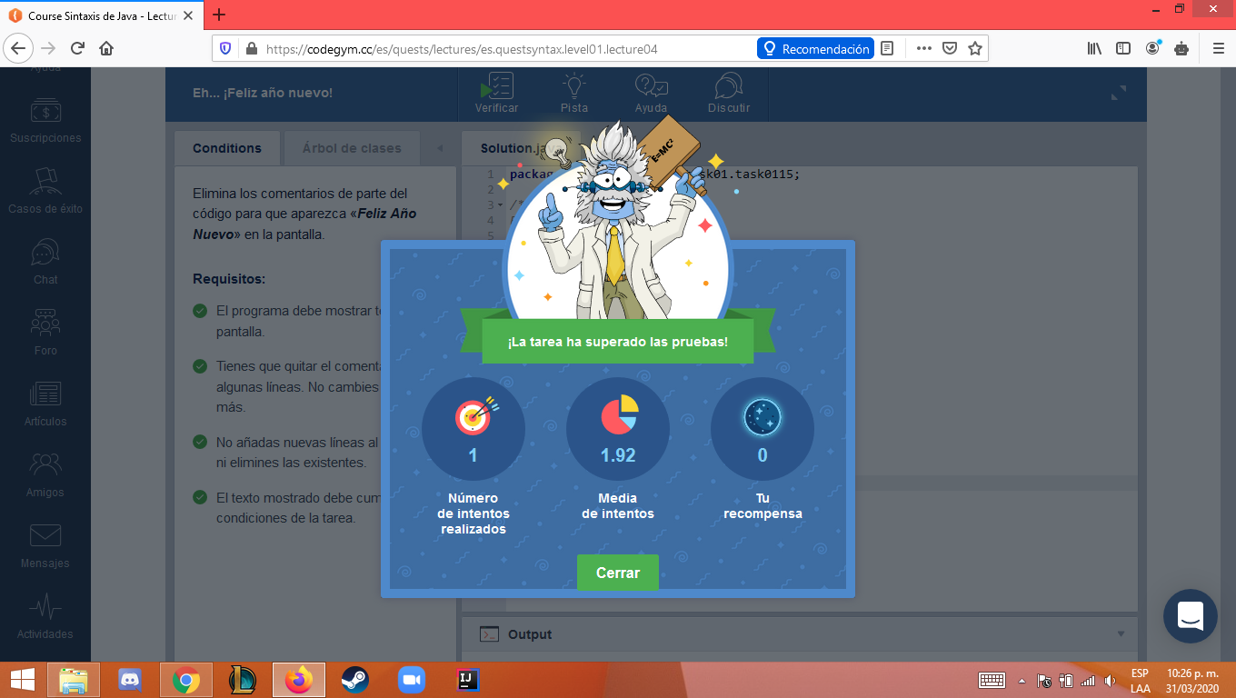

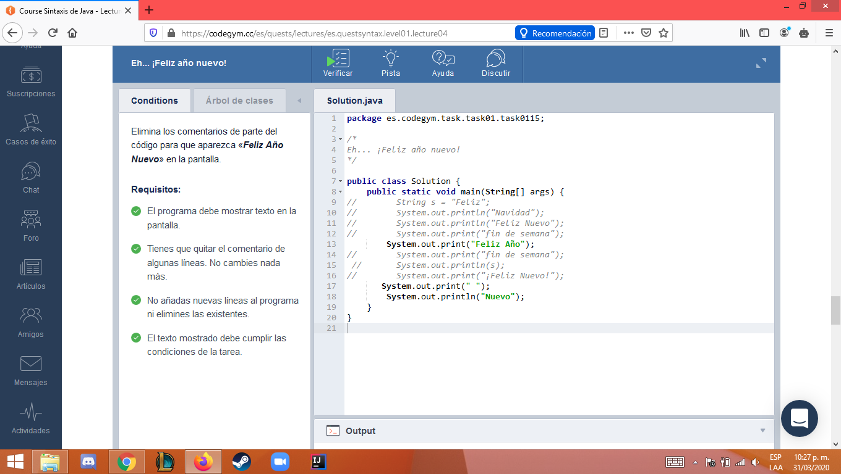

**N1_L4_E4**

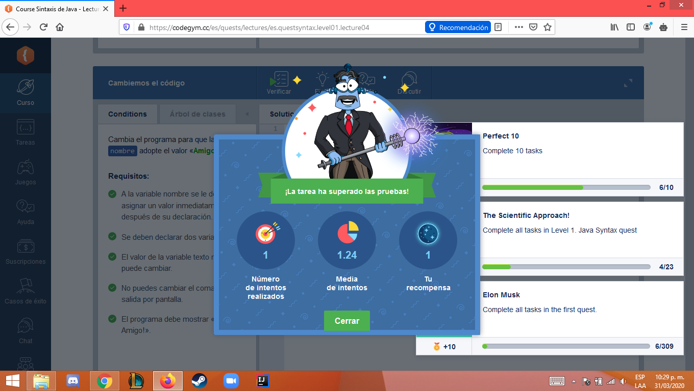

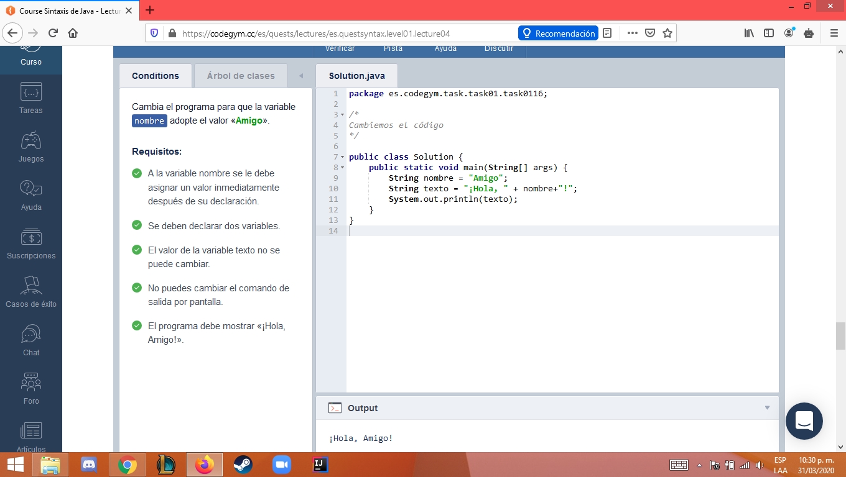

**N1_L4_E5**

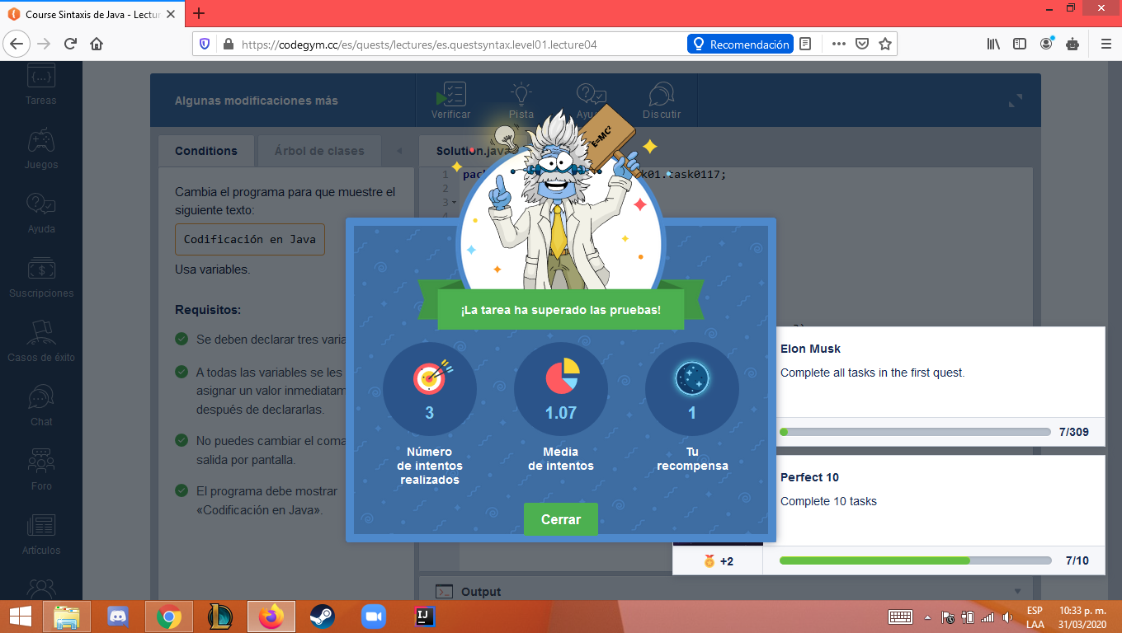

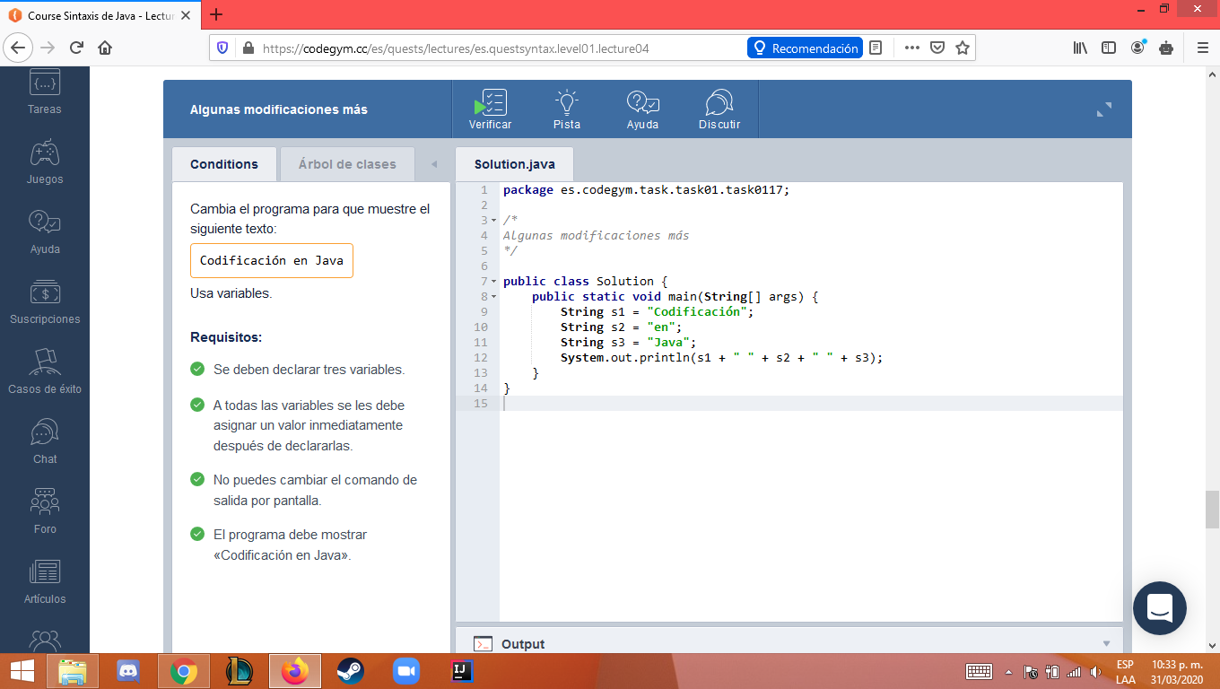

**N1_L4_E6**

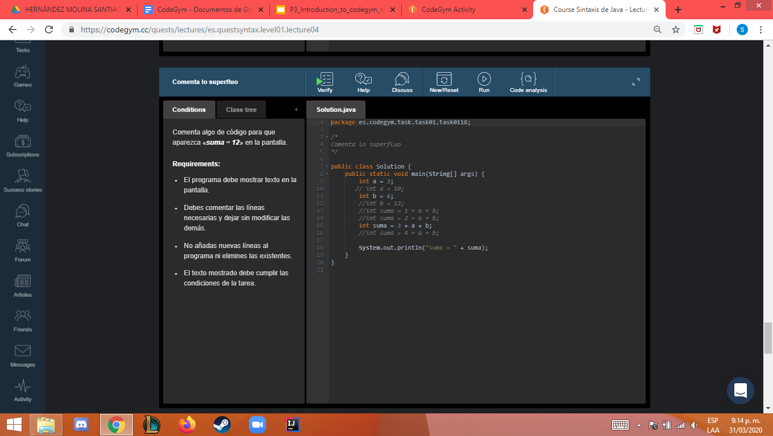



**N1_L4_E7**

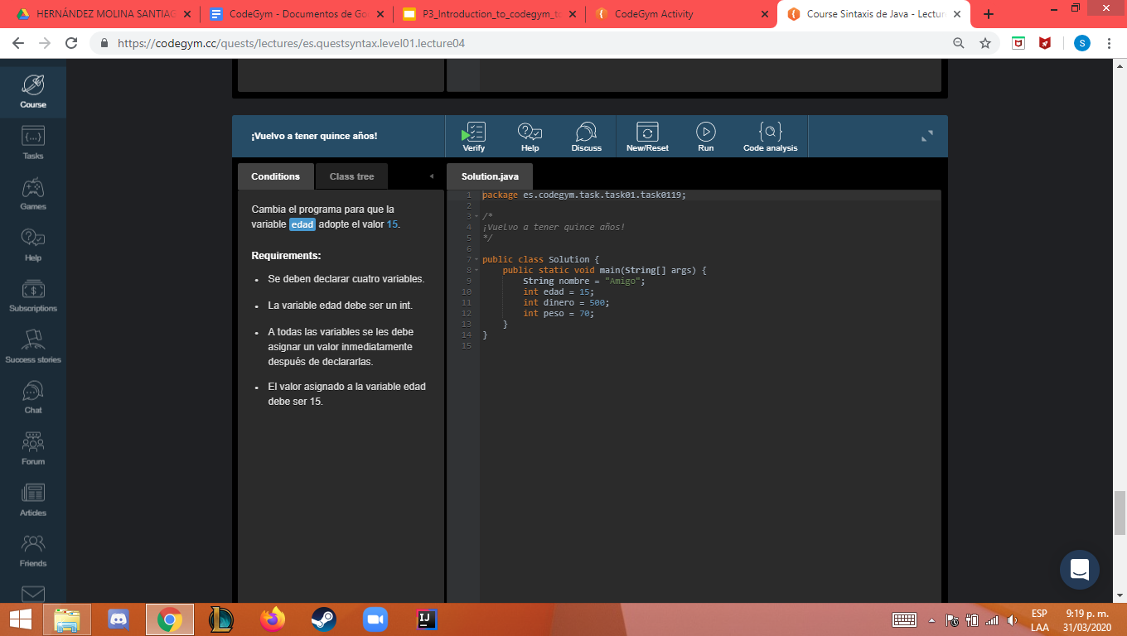



**N1_L5_E1**

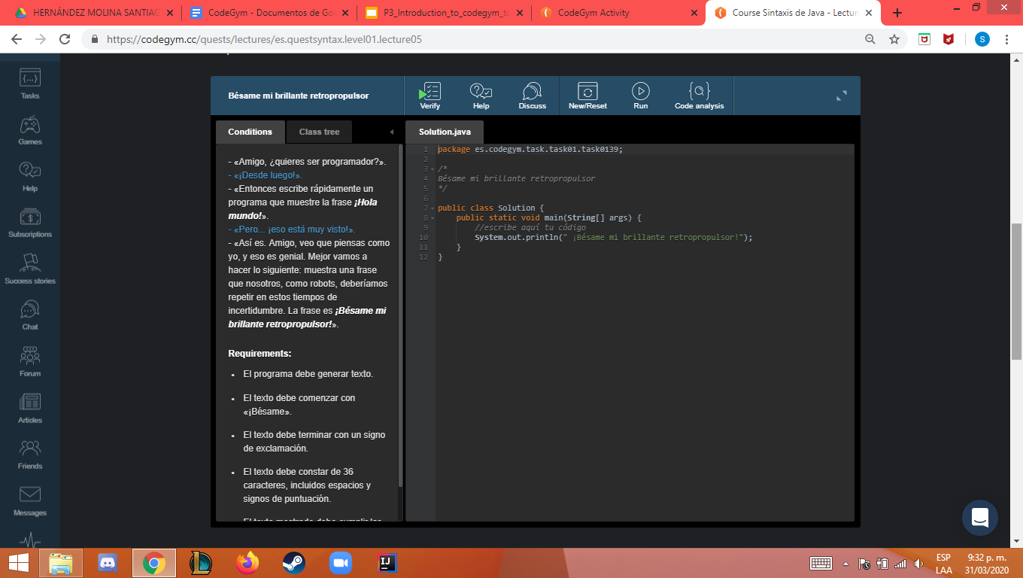

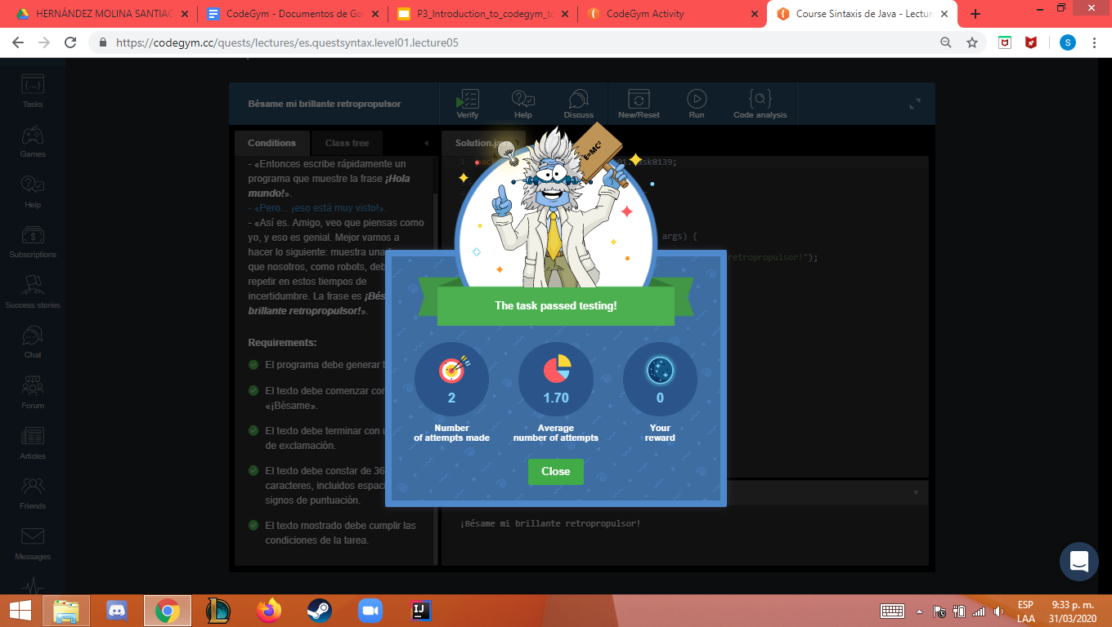

**N1_L6_E1**

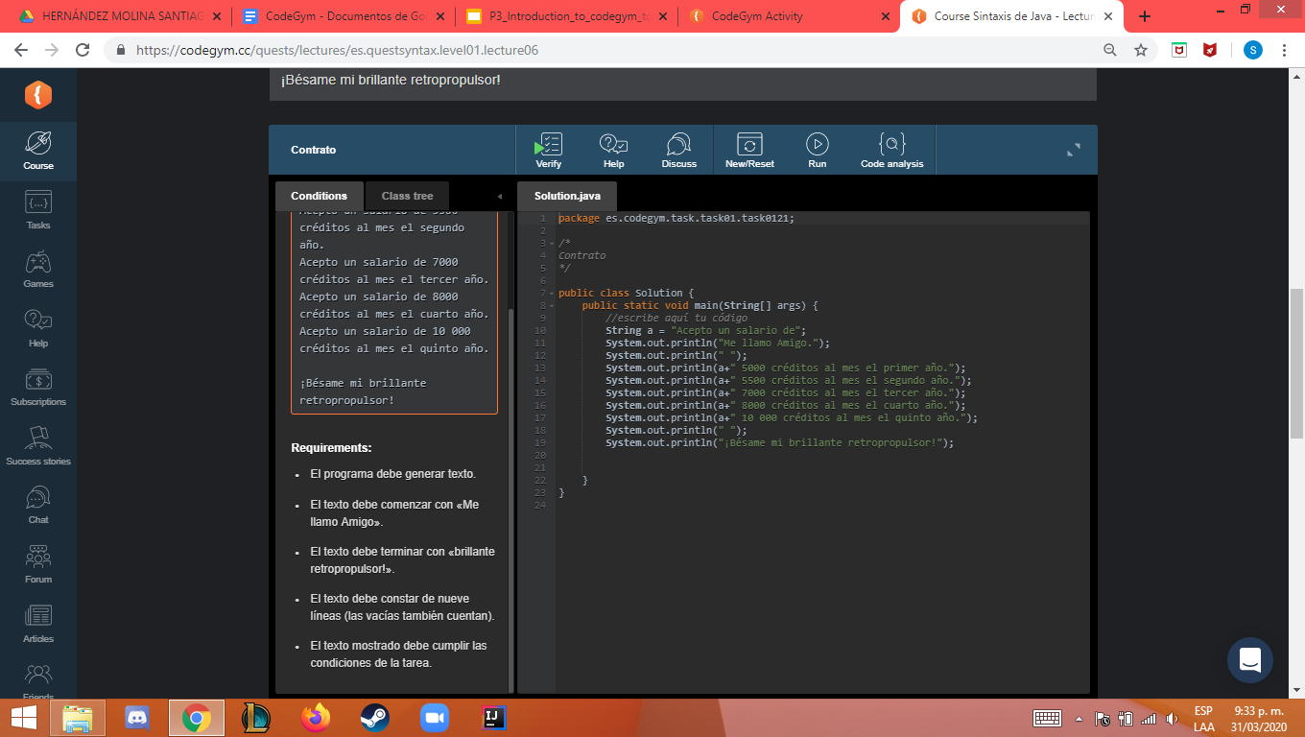

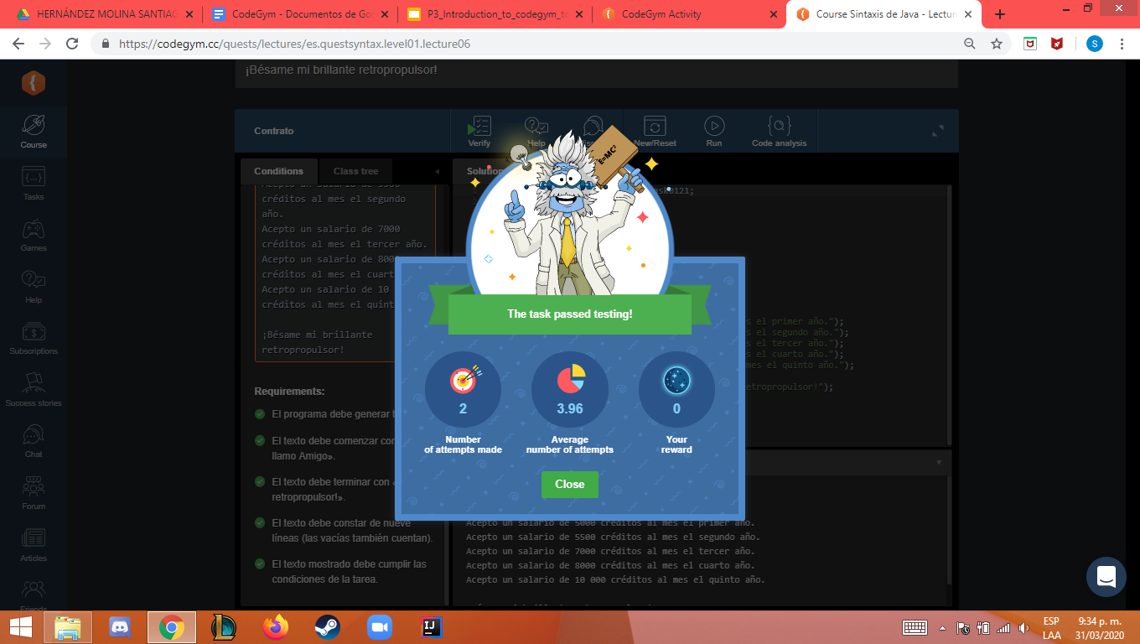

**N1_L7_E1**

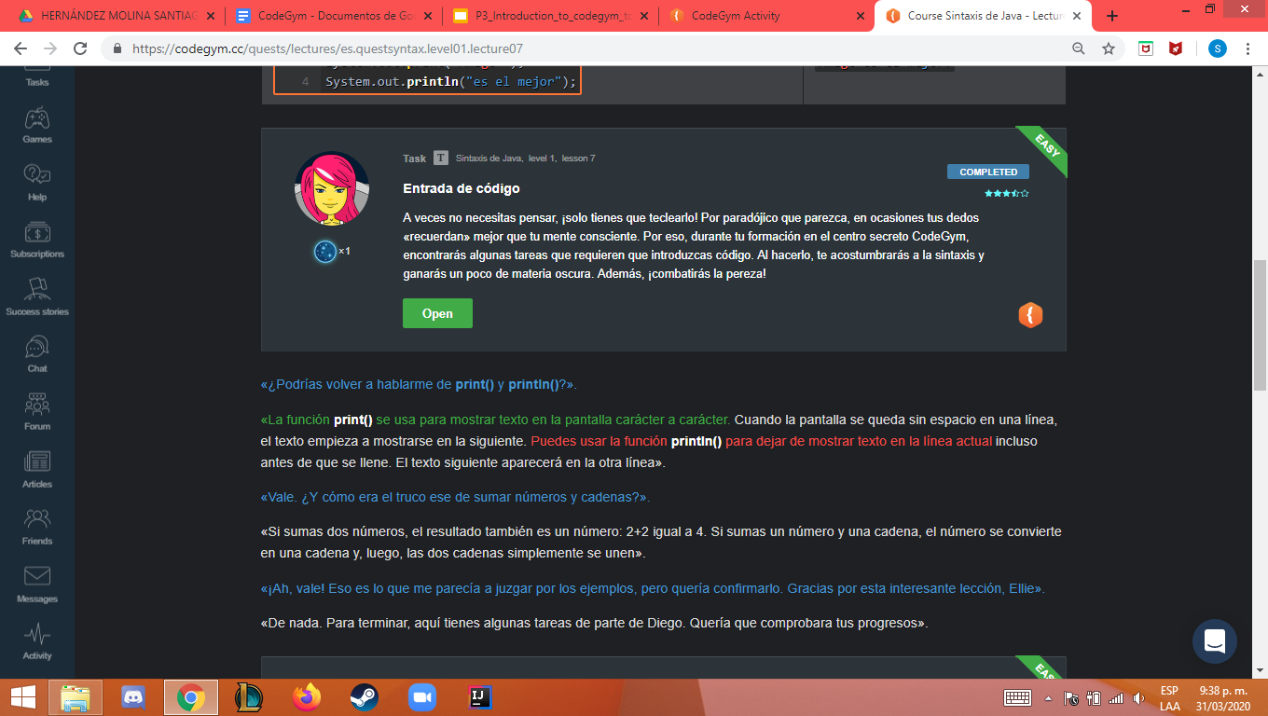

**N1_L7_E2**

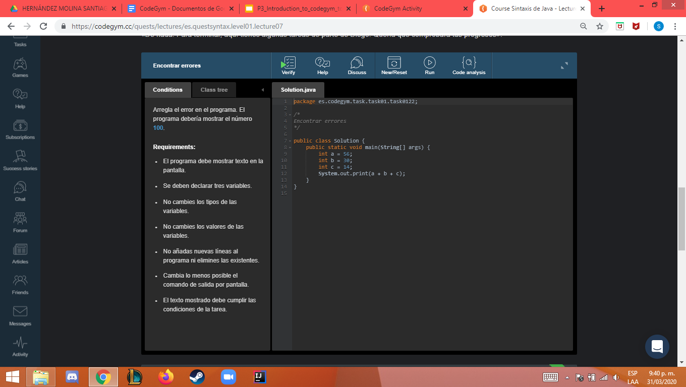



**N1_L7_E3**

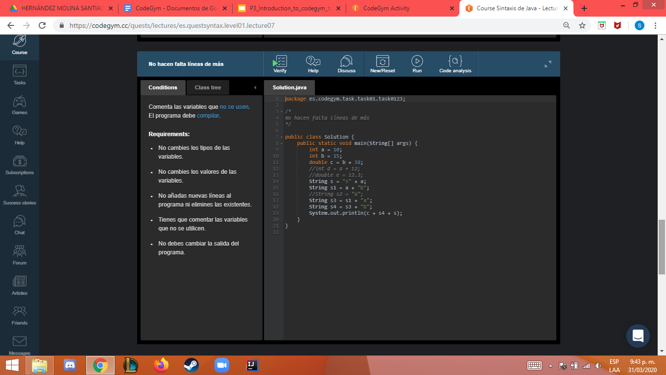

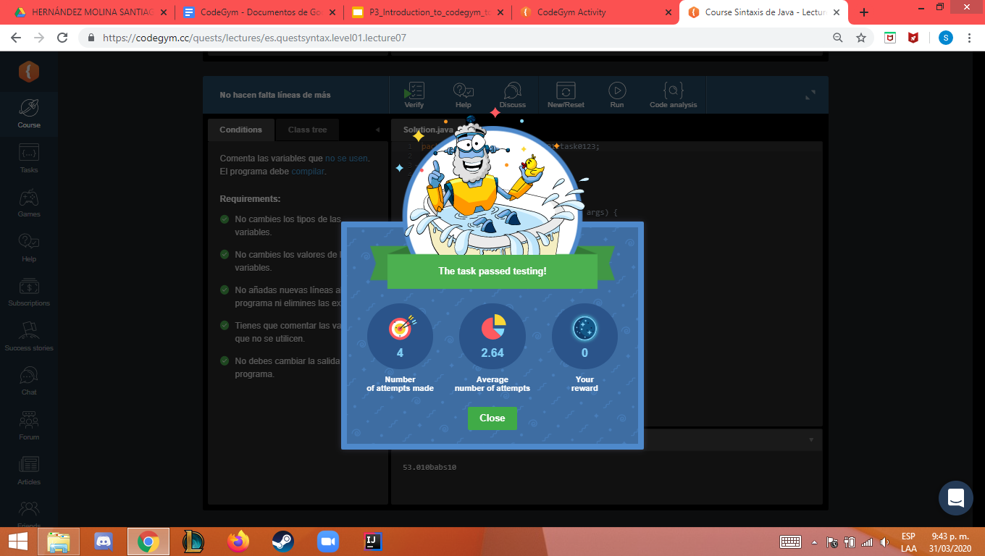

**N1_L8_E1**

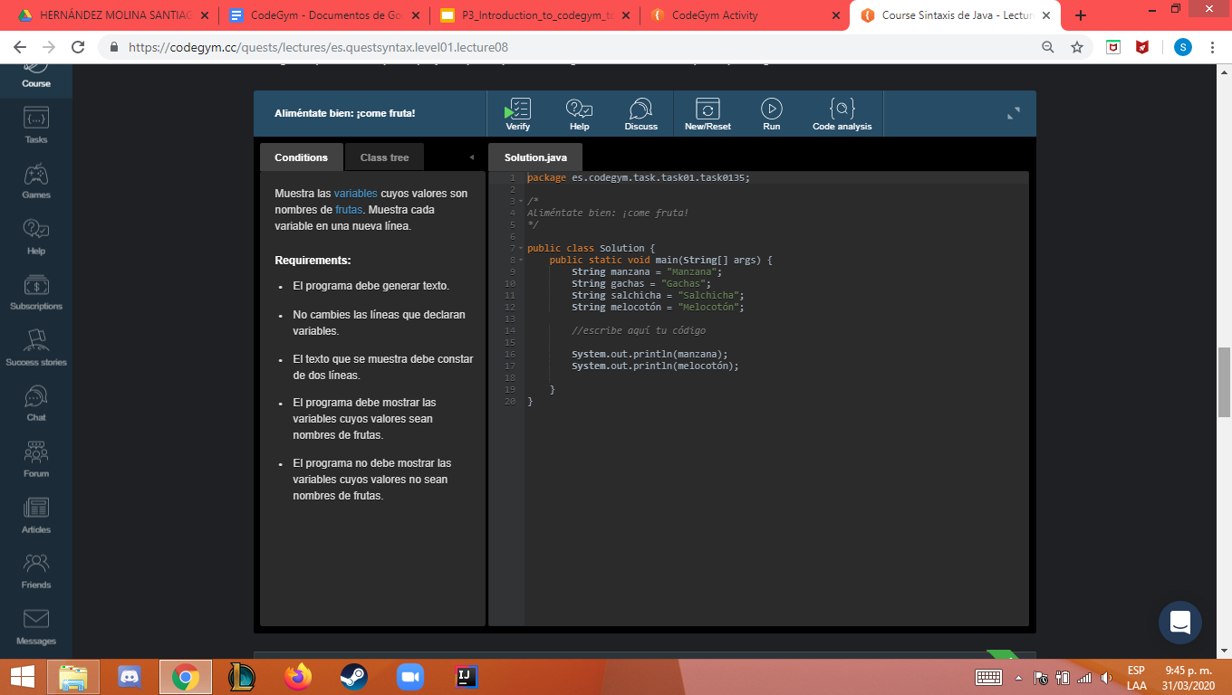



**N1_L8_E2**

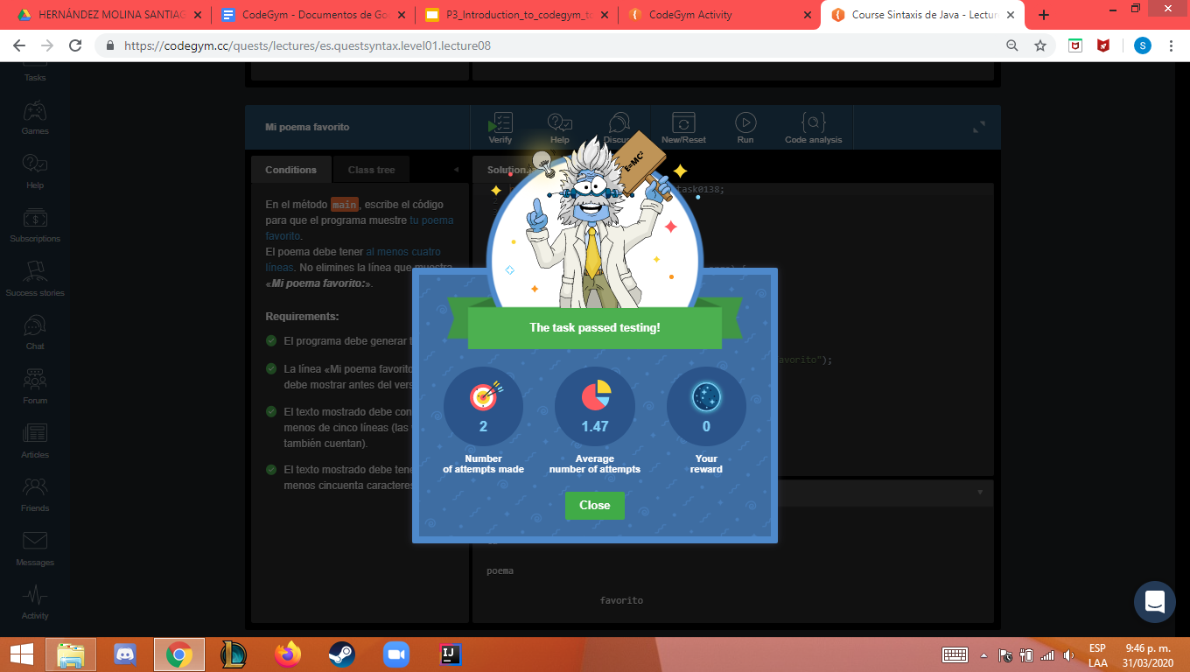

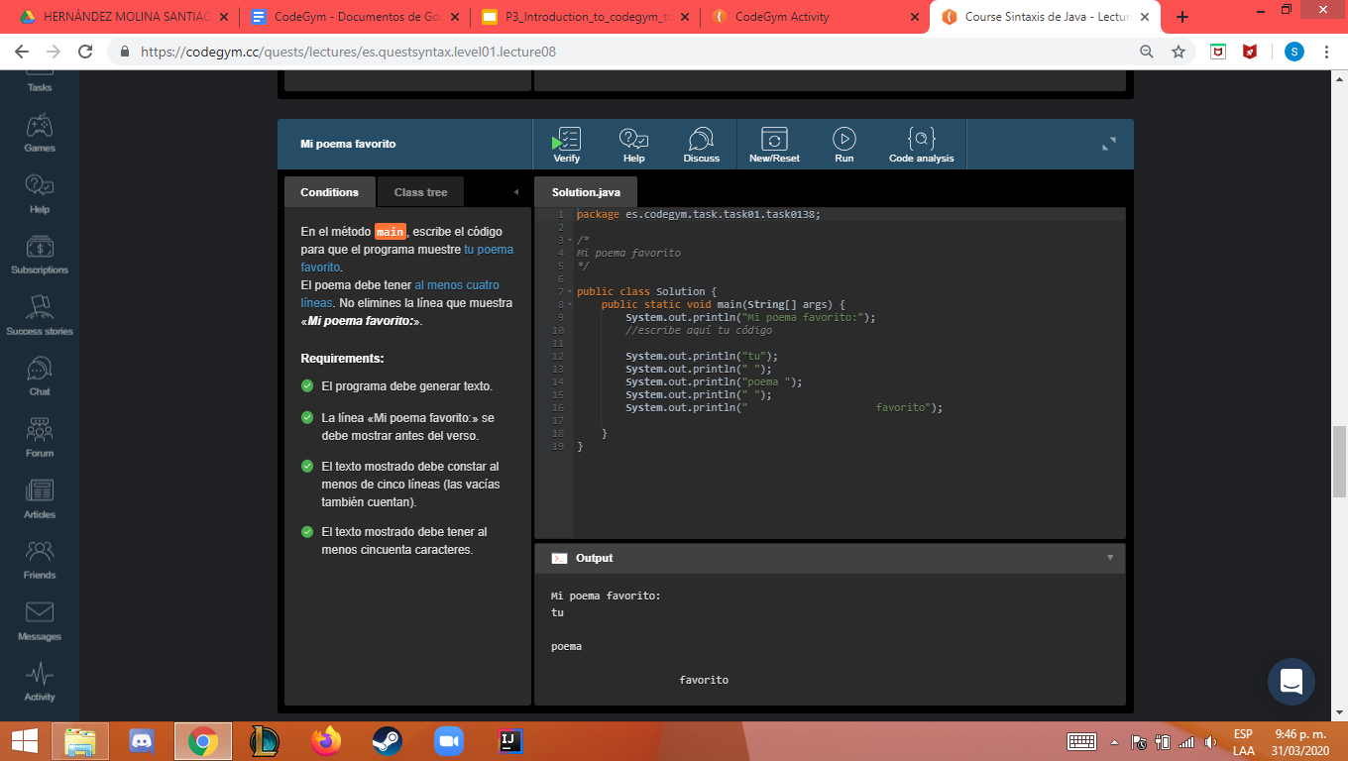

**N1_L8_E3**

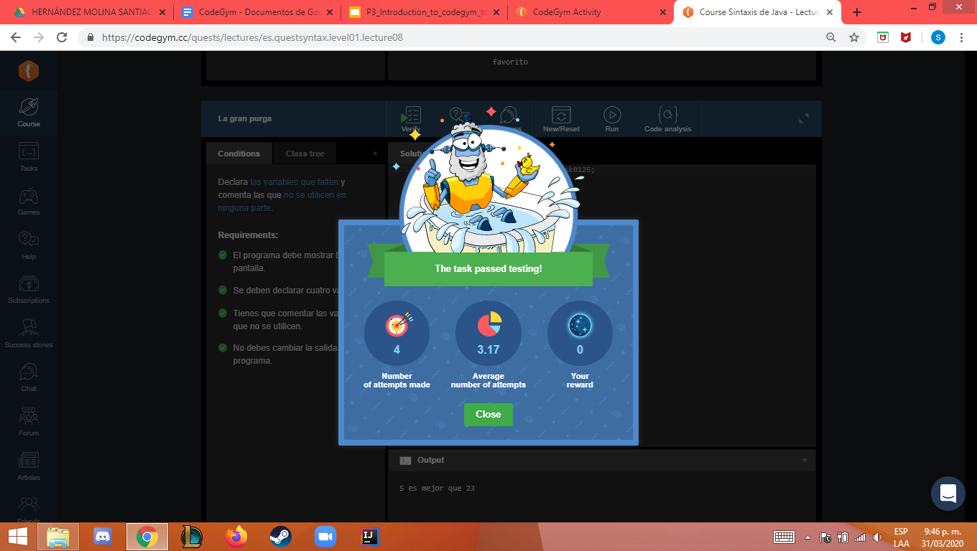

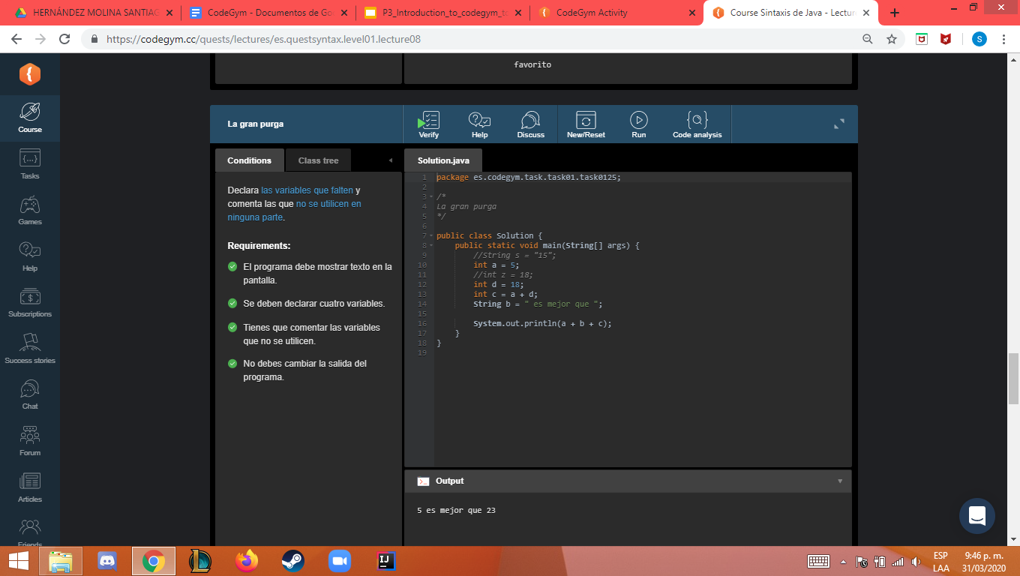

**N1_L8_E4**

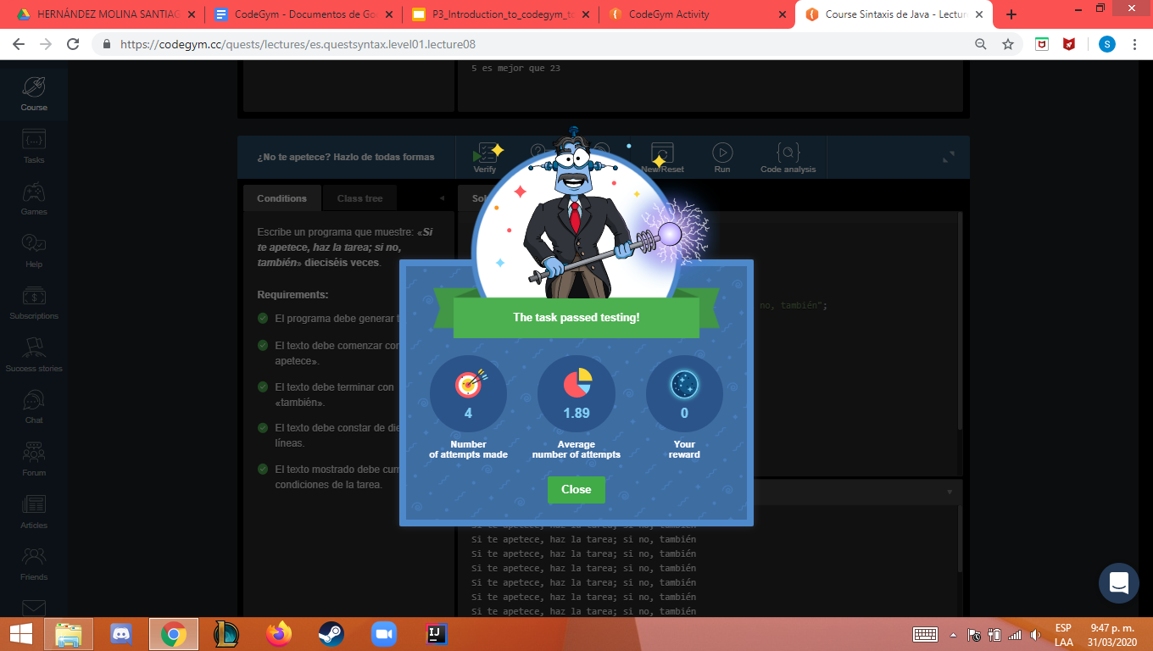

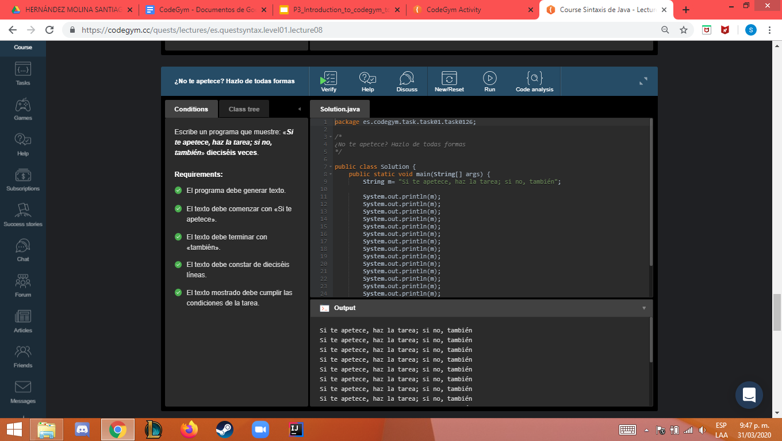

**N1_L8_E5**

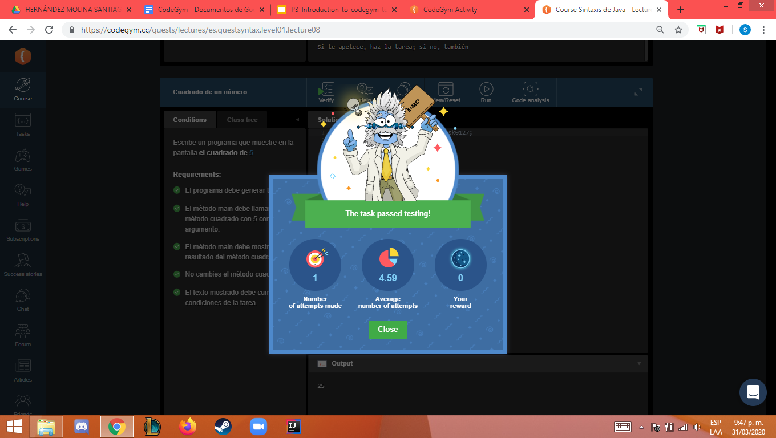

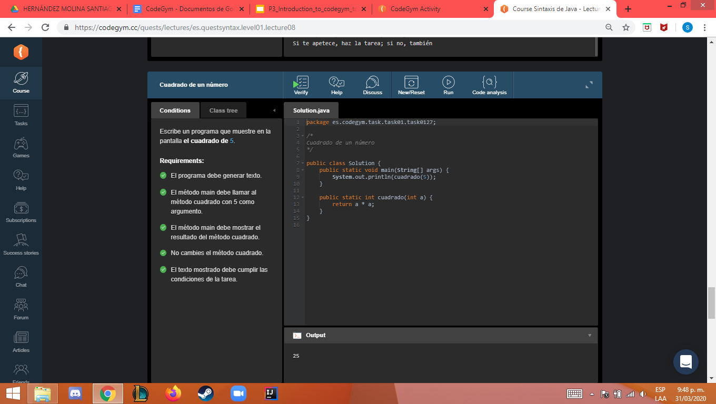

**N1_L8_E6**



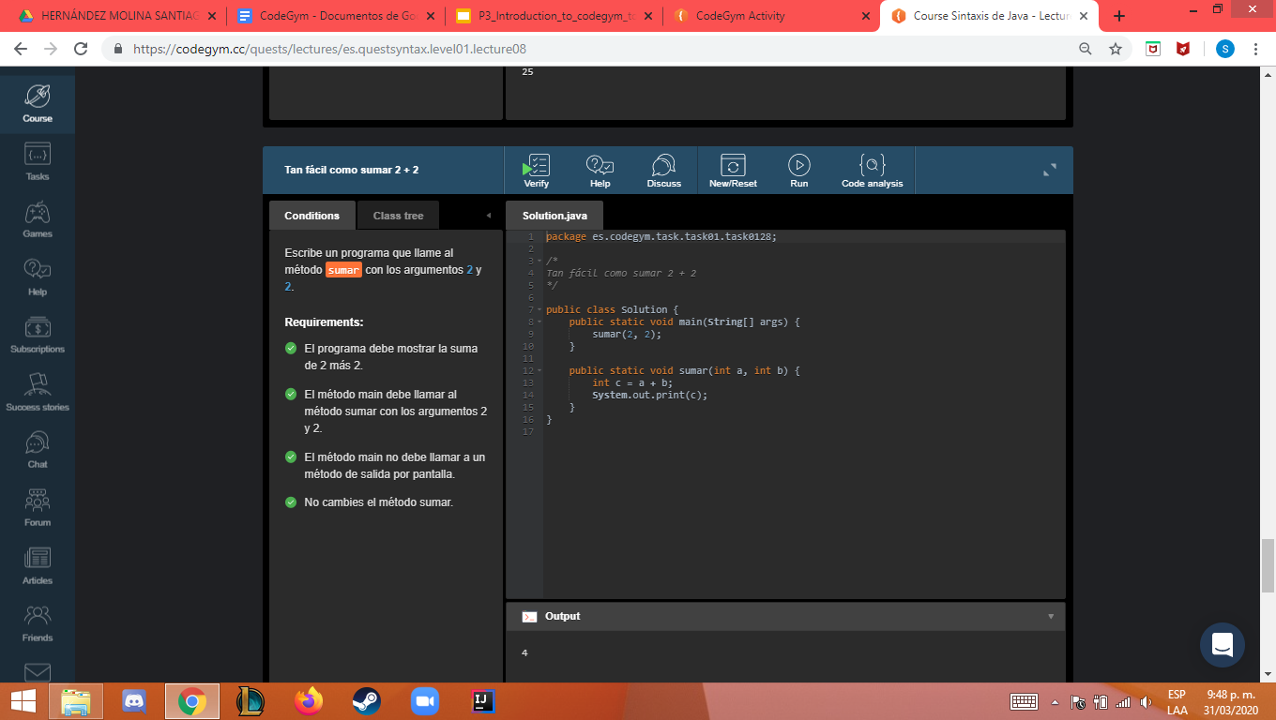



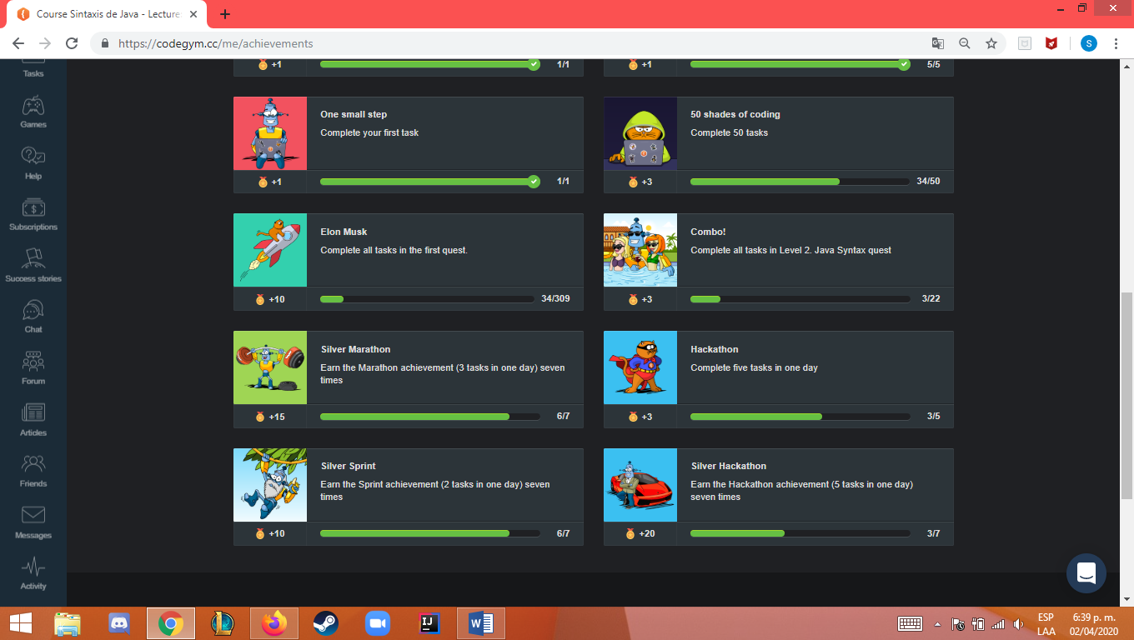

|  |  |  |  |  |  |  |  |  |  |  |  |  |  |
| --- | --- | --- | --- | --- | --- | --- | --- | --- | --- | --- | --- | --- | --- |
| **Ejercicios Nivel 2** | | | | | | | | | | | | | |
| **N2_L1_E1** | | **N2_L2_E1** | | **N2_L2_E2** | | **N1_L2_E3** | | **N2_L2_E4** | | **N2_L2_E5** | | **N2_L3_E1** | |
|  |  |  |  |  |  |  |  |  |  |  |  |  |  |
| **Ejercicios Nivel 2** | | | | | | | | | | | | | |
| **N2_L1_E1** | | **N2_L2_E1** | | **N2_L2_E2** | | **N1_L2_E3** | | **N2_L2_E4** | | **N2_L2_E5** | | **N2_L3_E1** | |
|  |  |  |  |  |  |  |  |  |  |  |  |  |  |

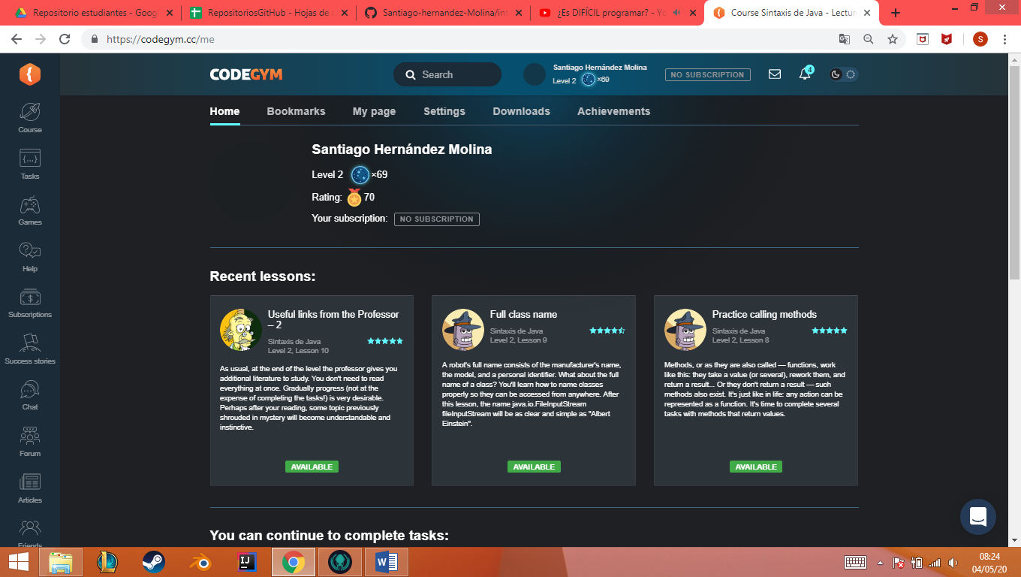

**N2_L1_E1**

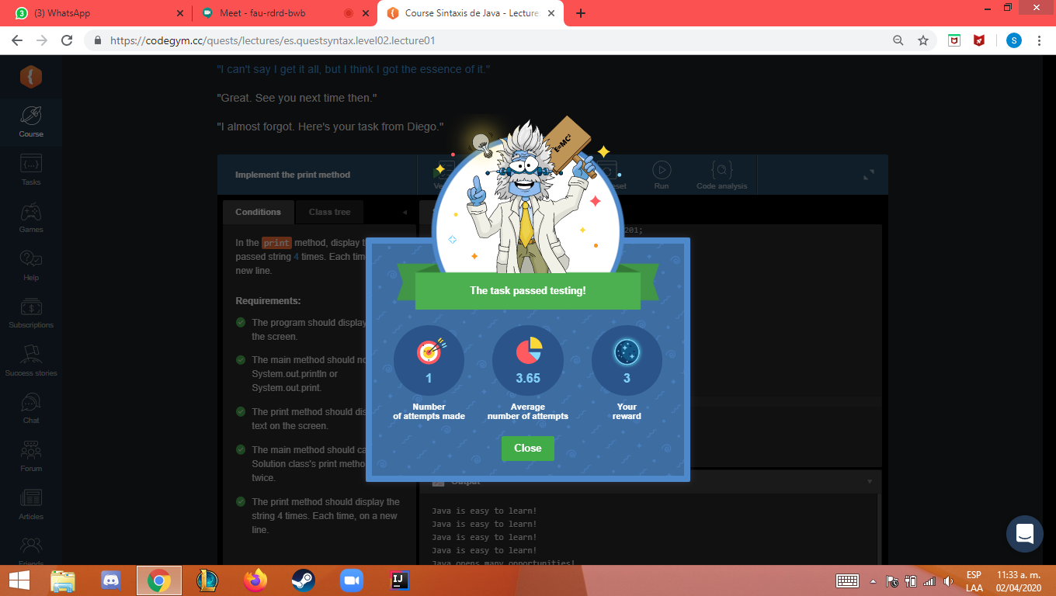

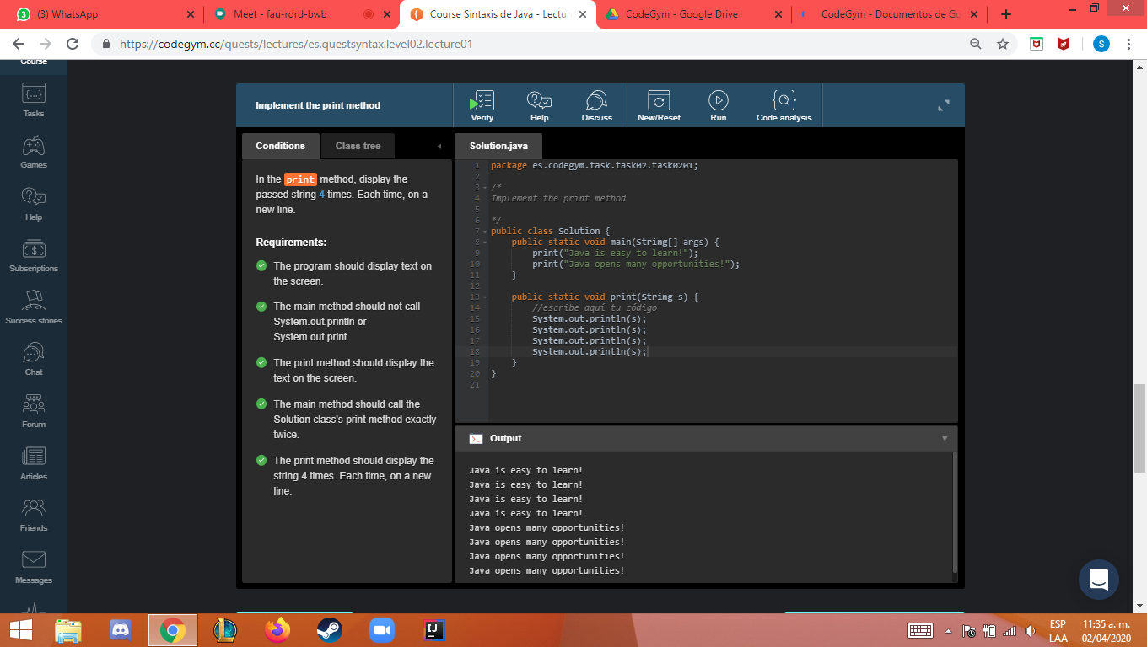

**N2_L2_E1**

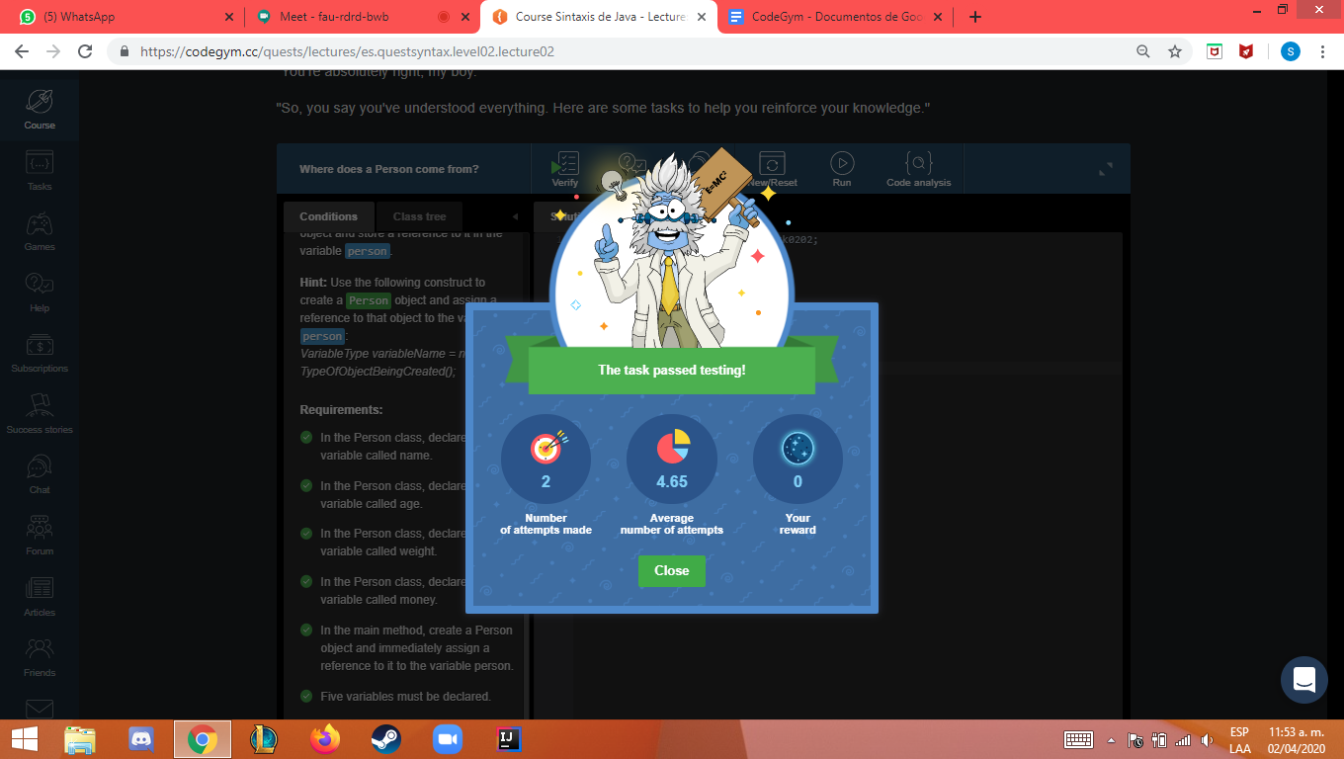

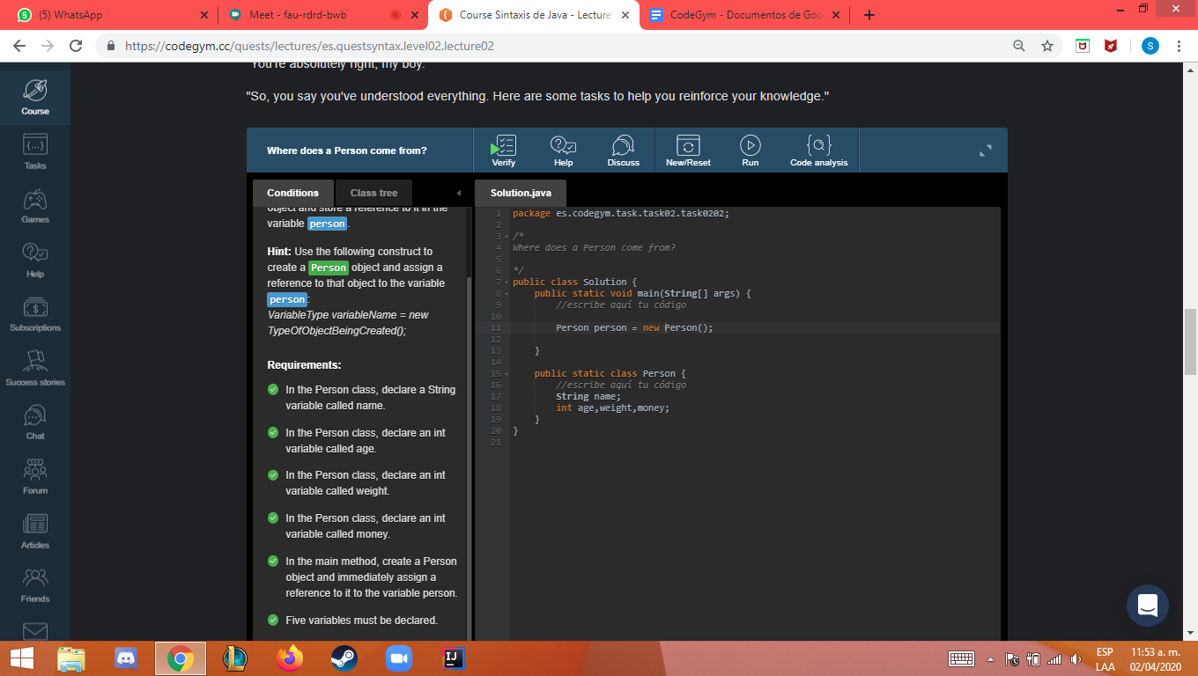

**N2_L2_E2**

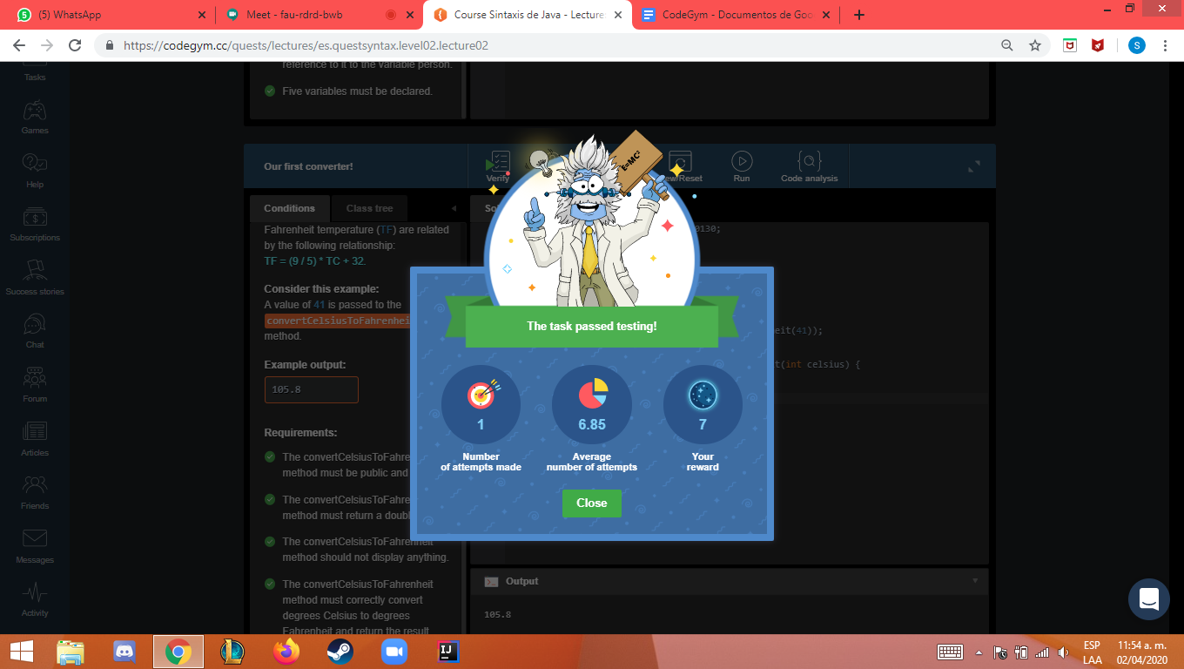

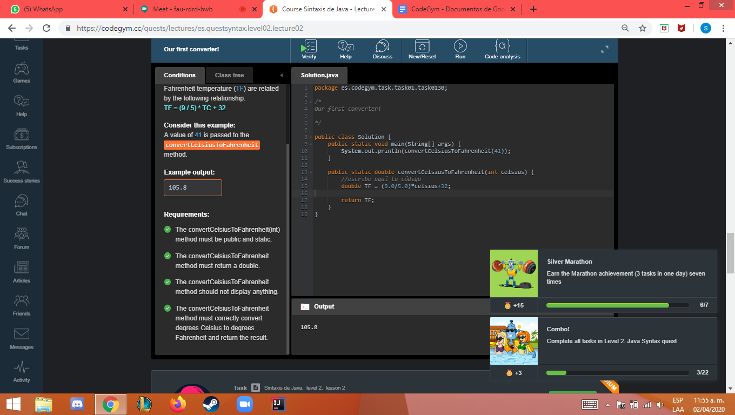

Nivel2 leccion2 ejercicio3

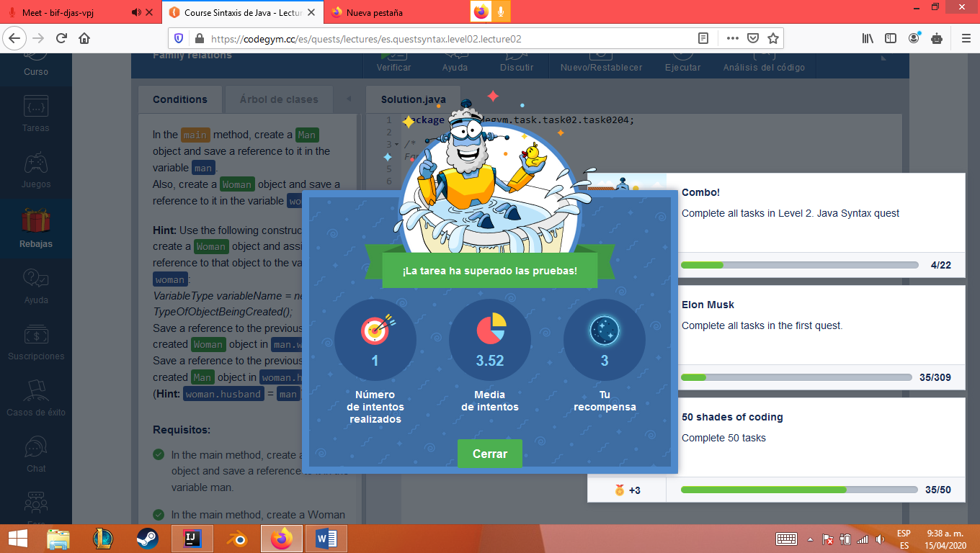

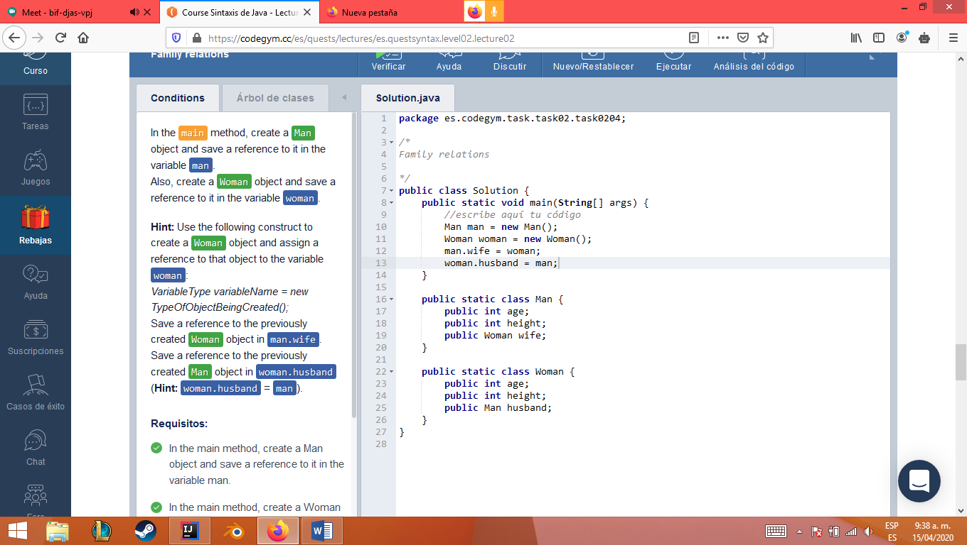

Nivel2 leccion2 ejercicio4

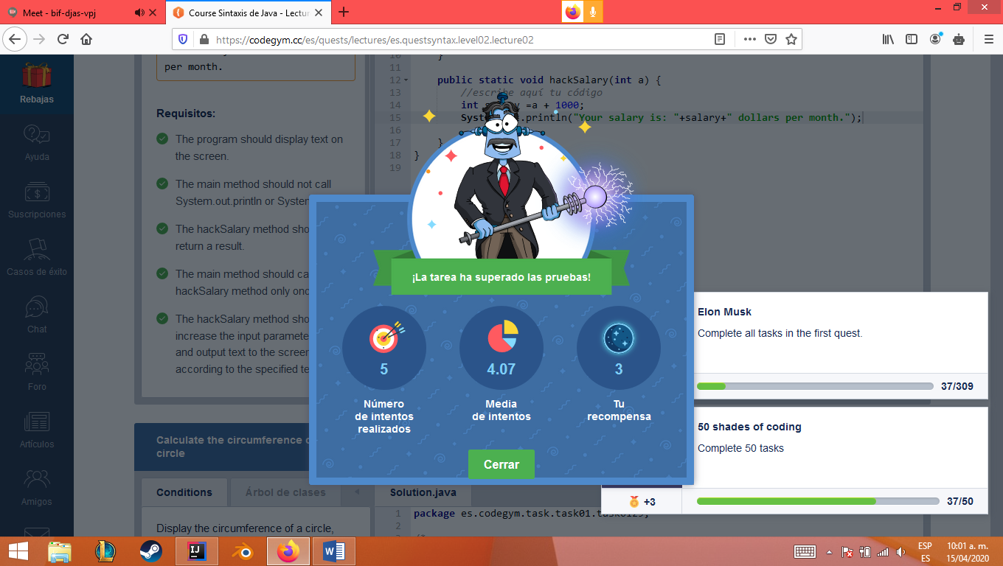

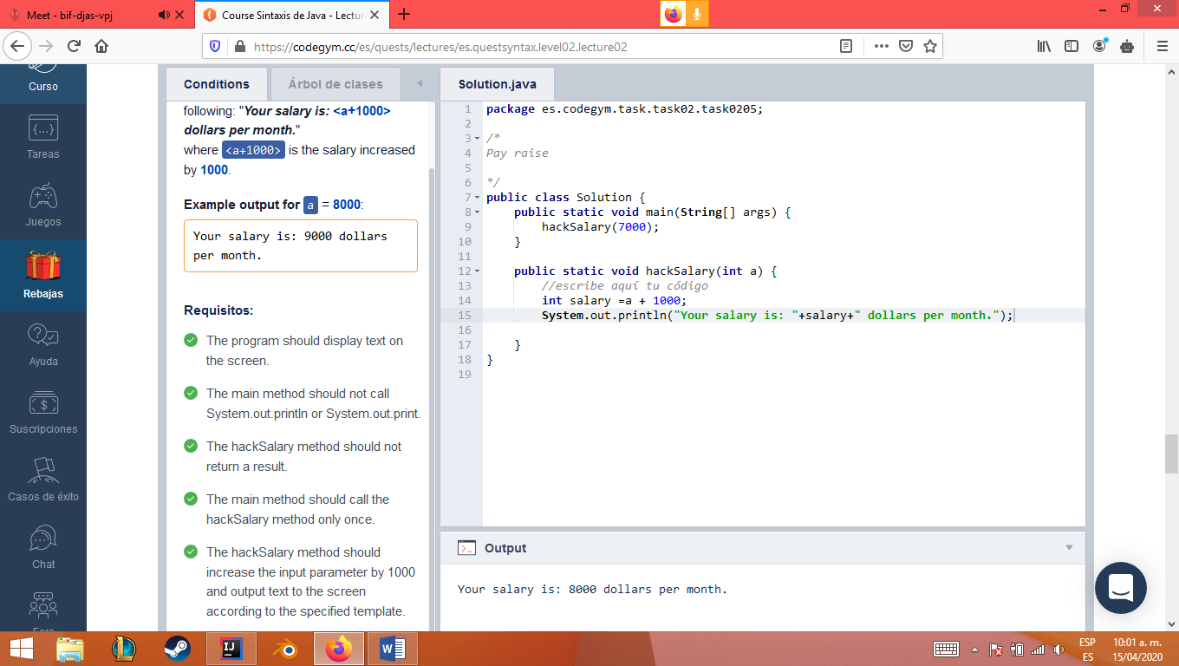

Nivel2 leccion2 ejercicio5

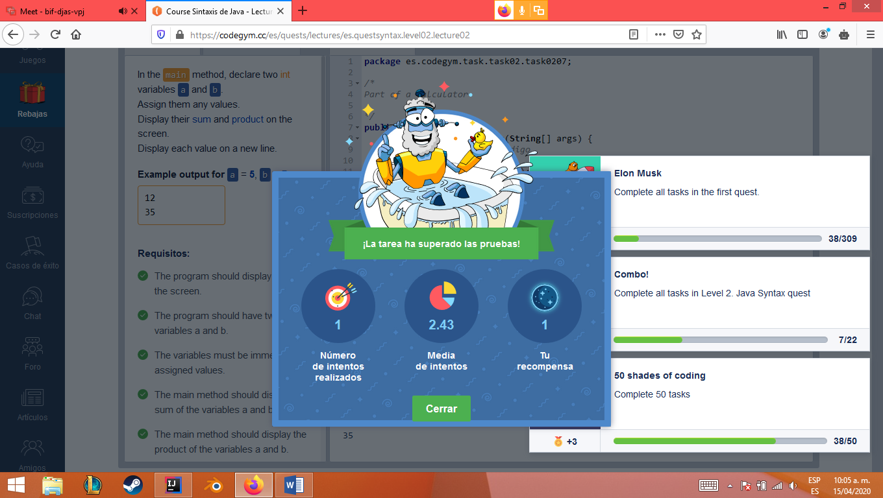

Nivel2 leccion3 ejercicio1

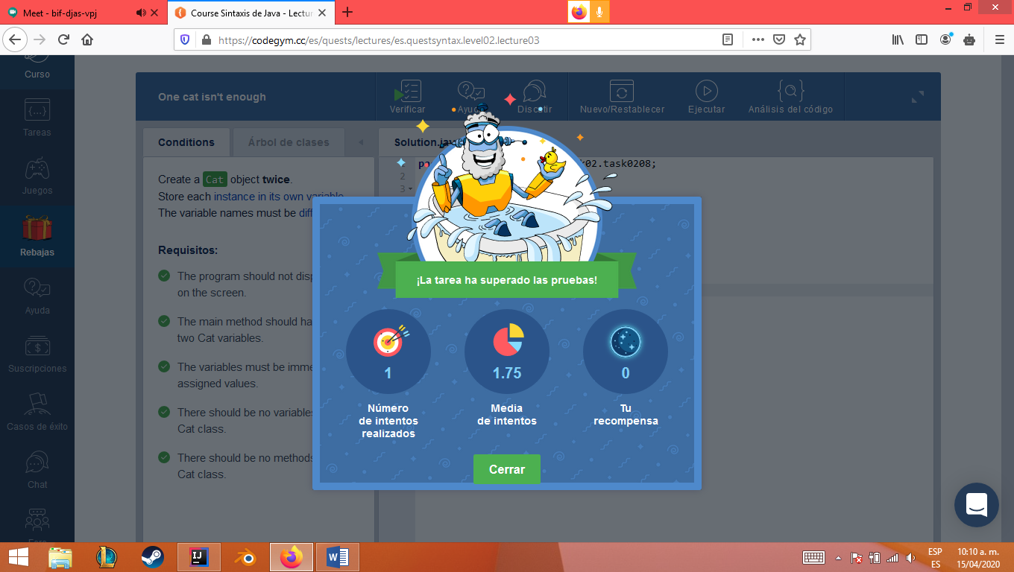

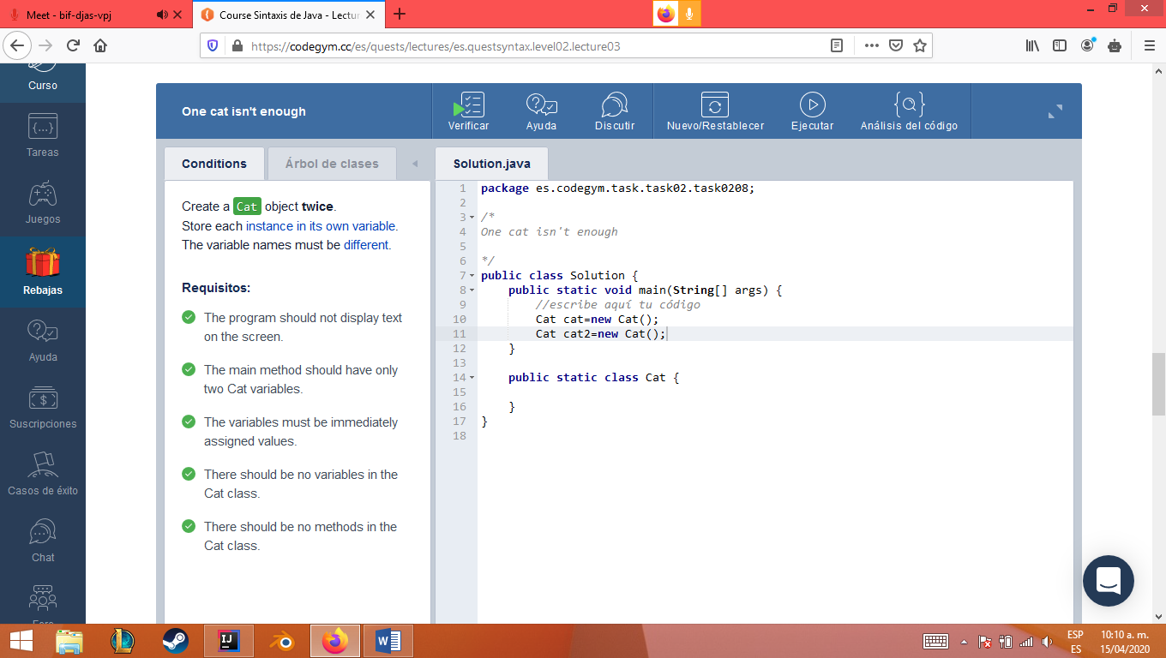

Nivel2 leccion3 ejercicio2

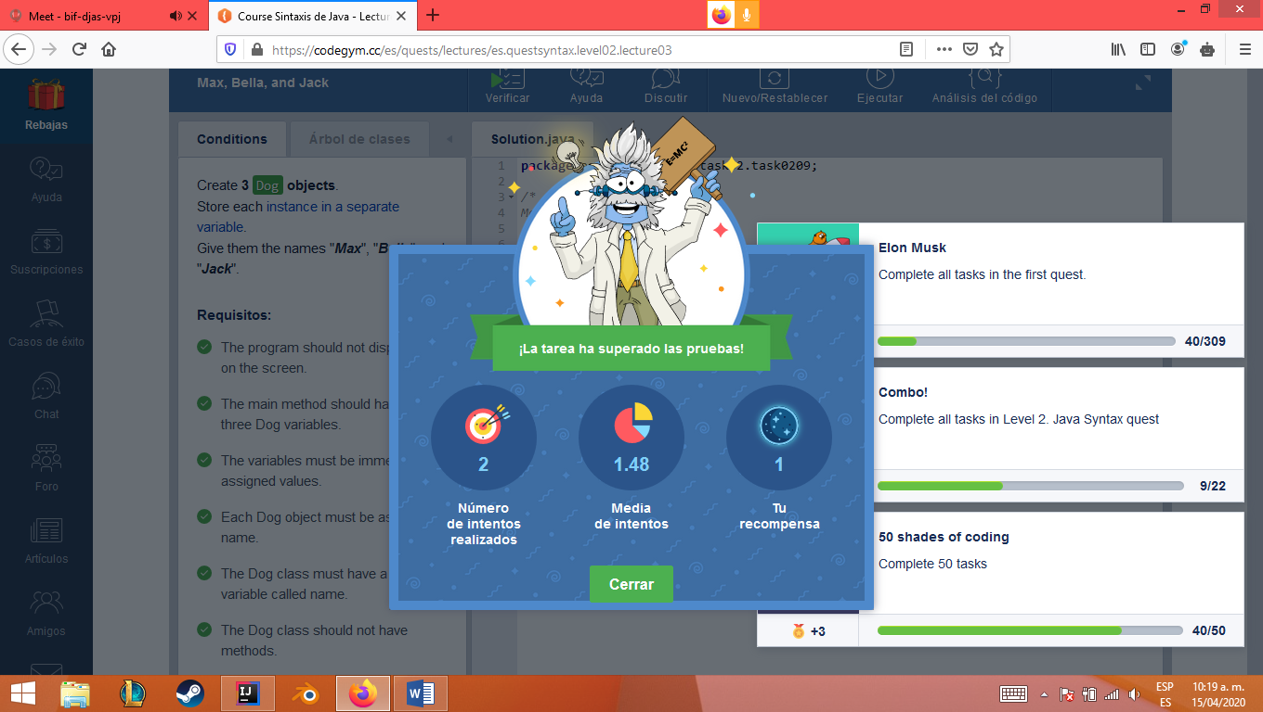

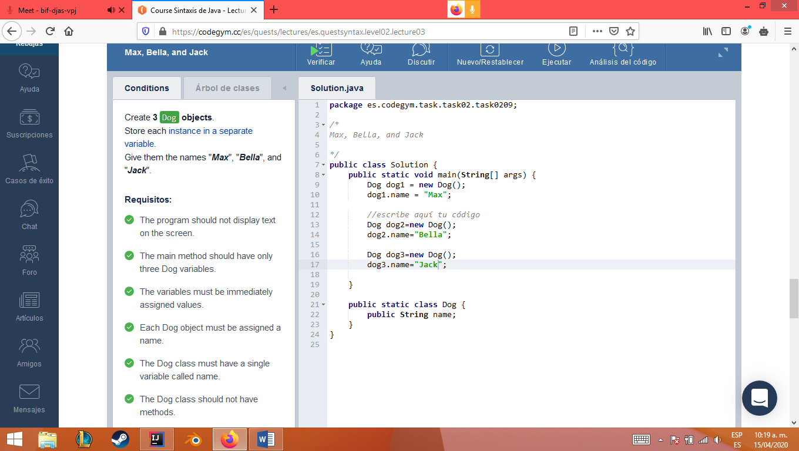

Nivel2 leccion3 ejercicio3

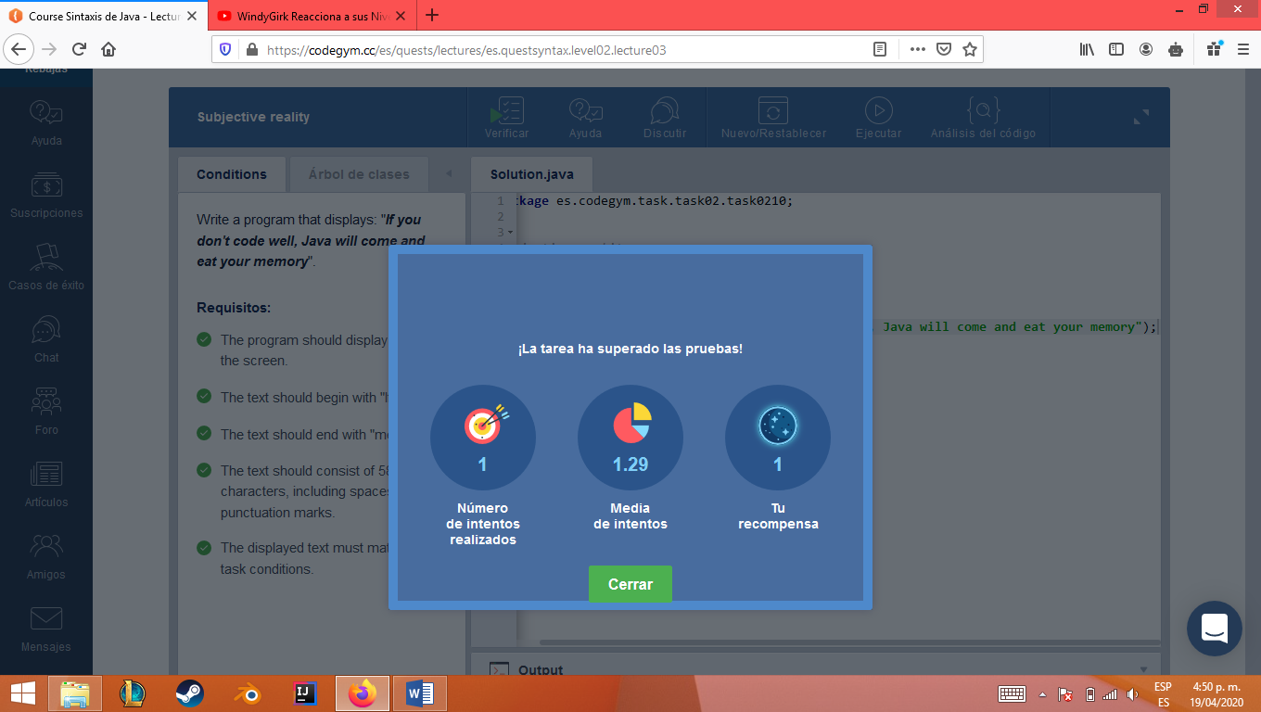

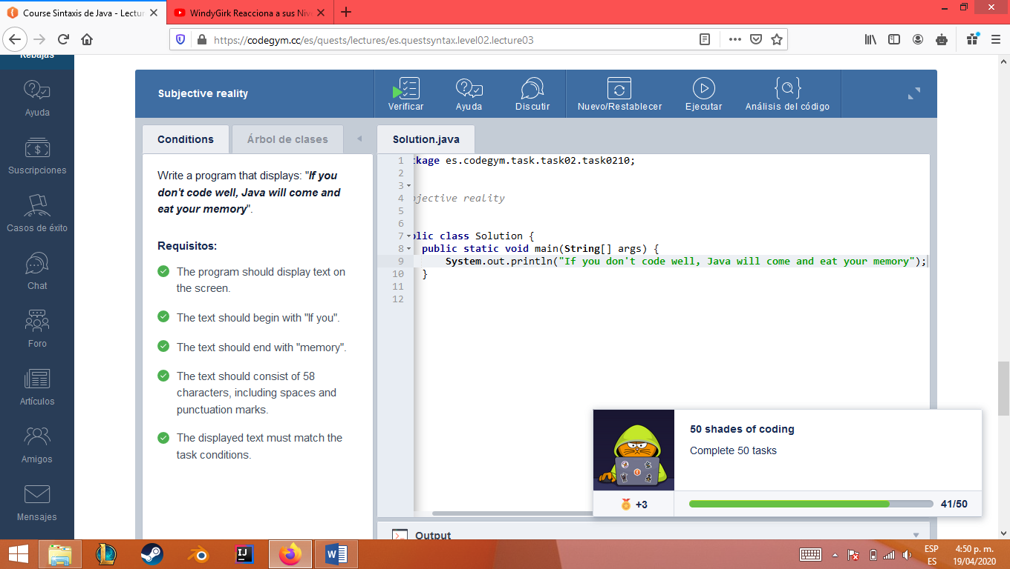

Nivel2 leccion5 ejercicio1

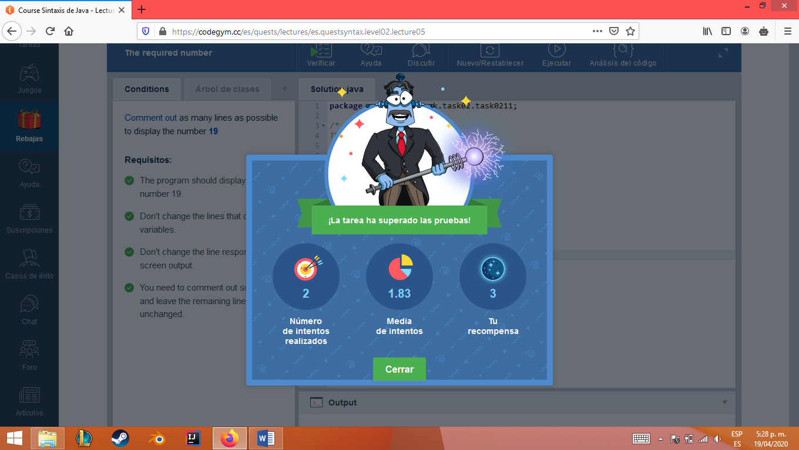

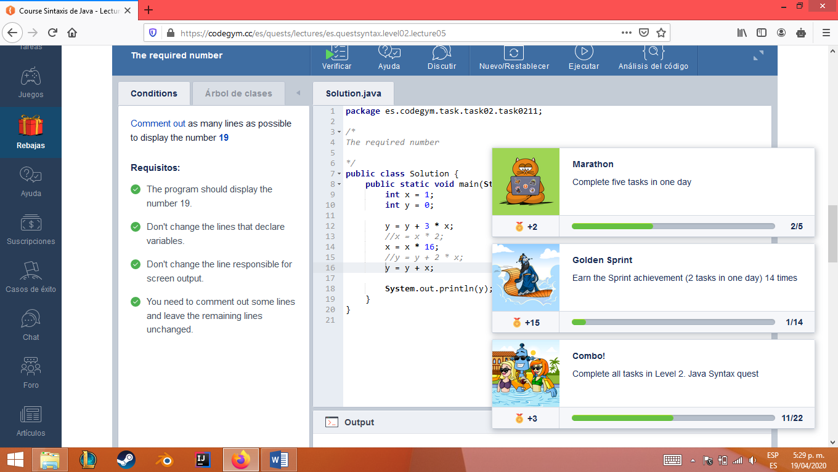

Nivel2 leccion5 ejercicio2

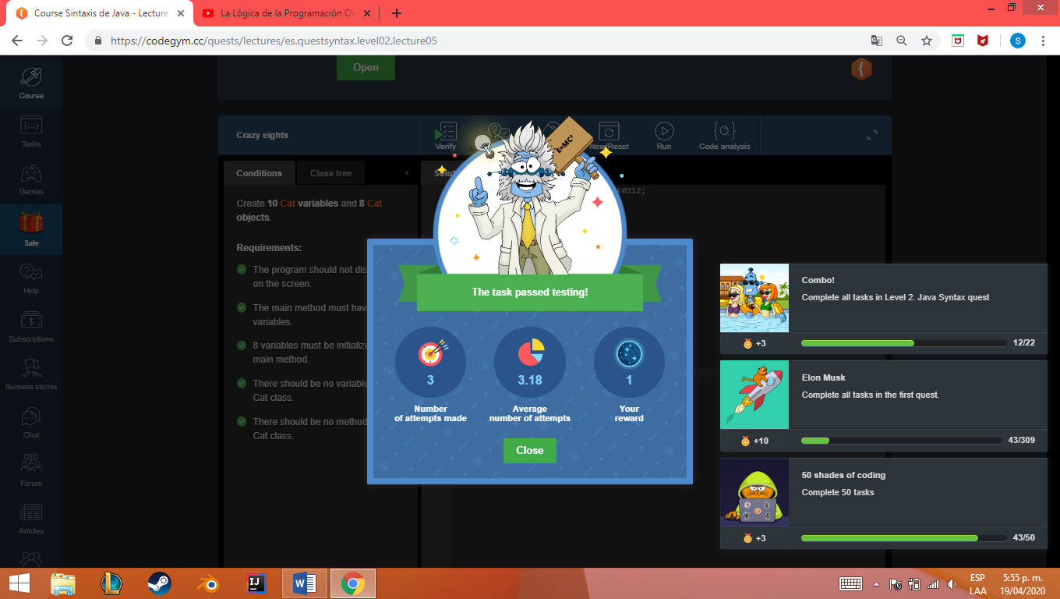

Nivel2 leccion5 ejercicio3

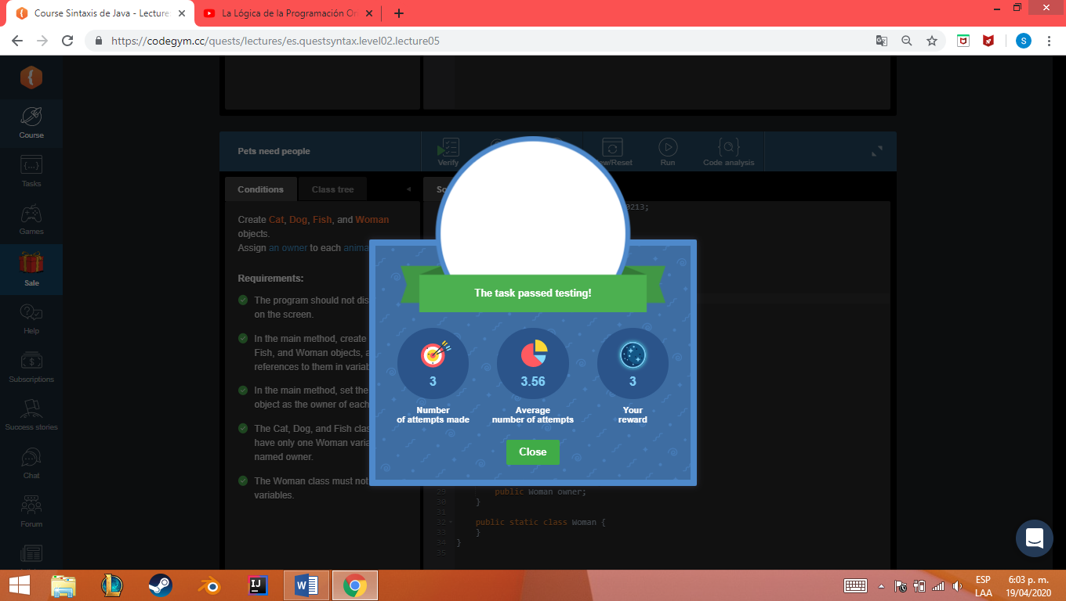

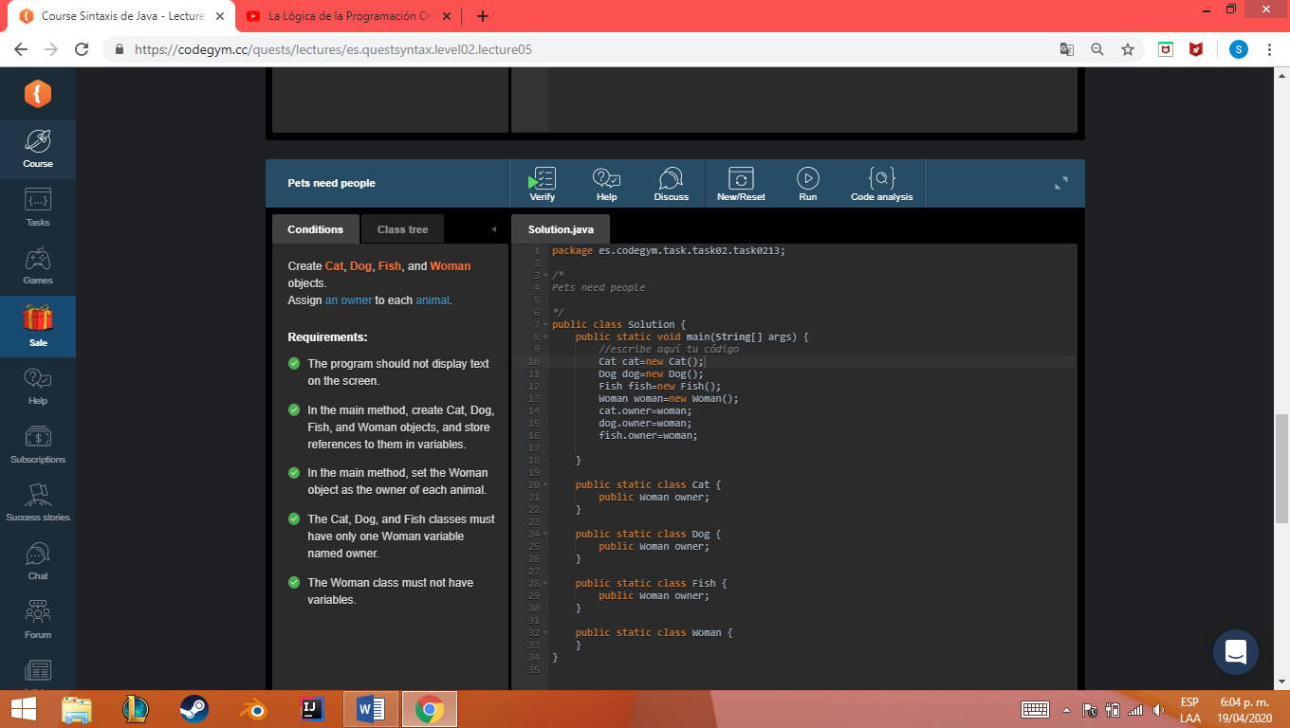

Nivel2 leccion8 ejercicio1

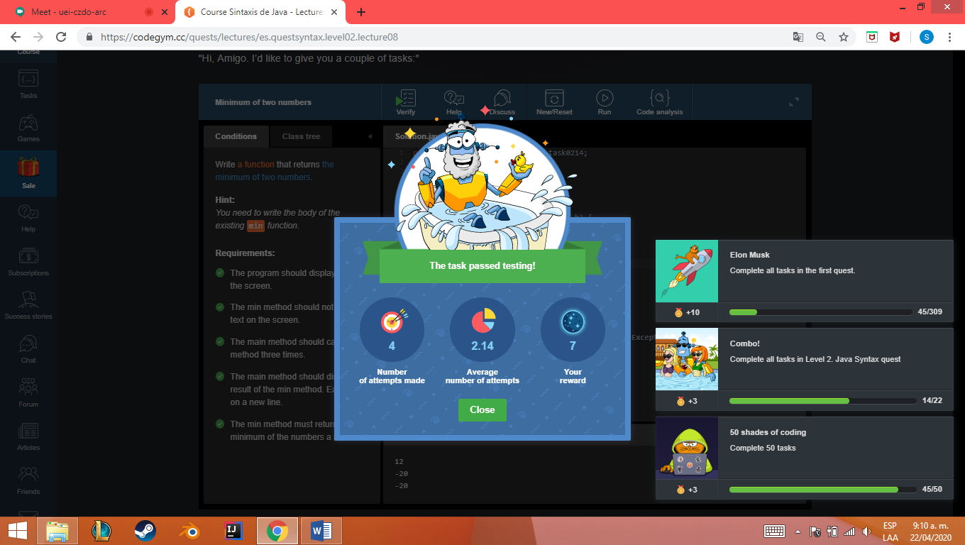

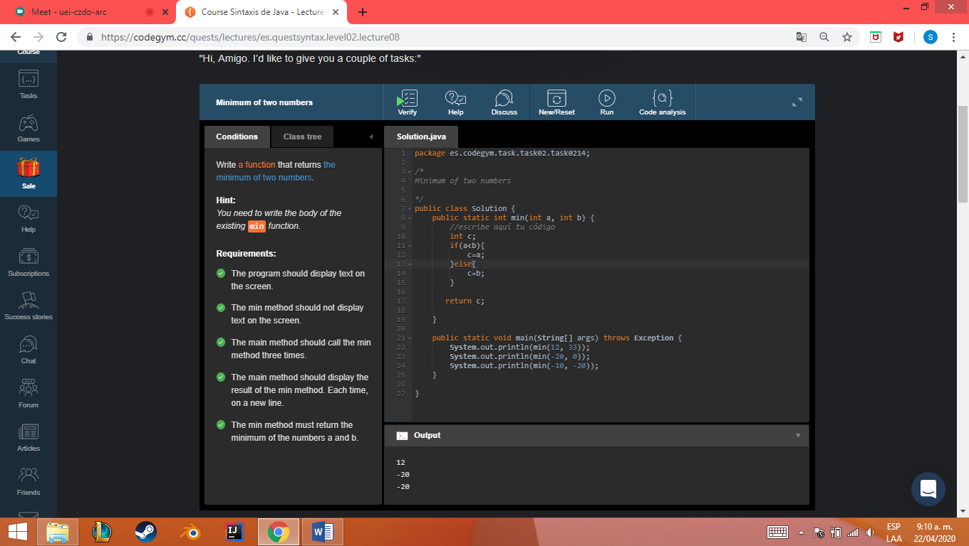

Nivel2 leccion8 ejercicio2



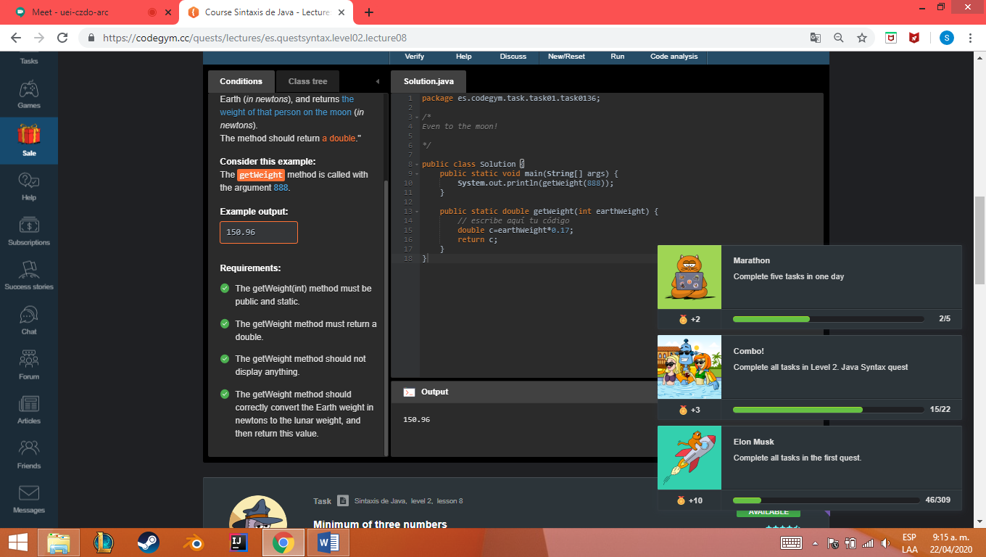

Nivel2 leccion8 ejercicio3

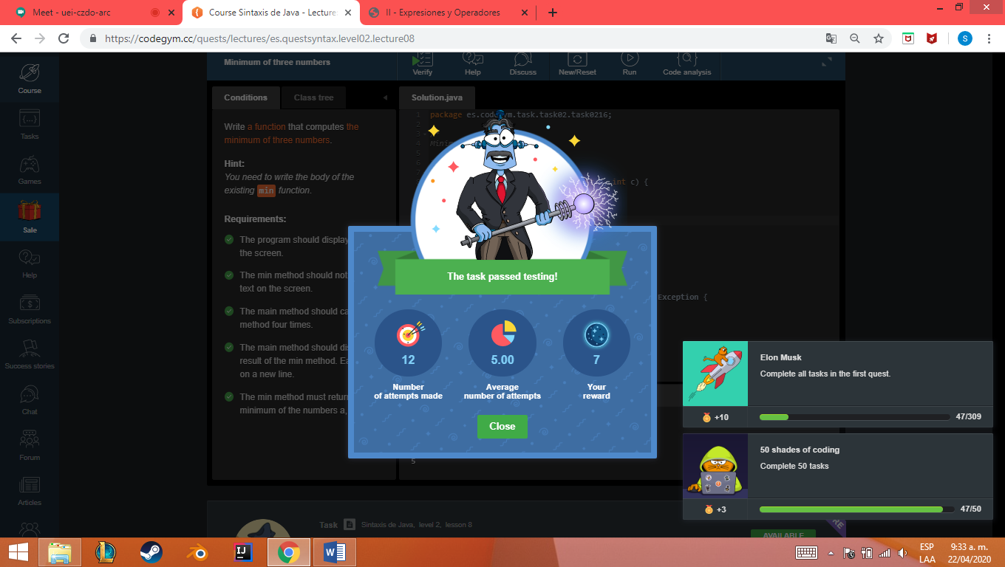

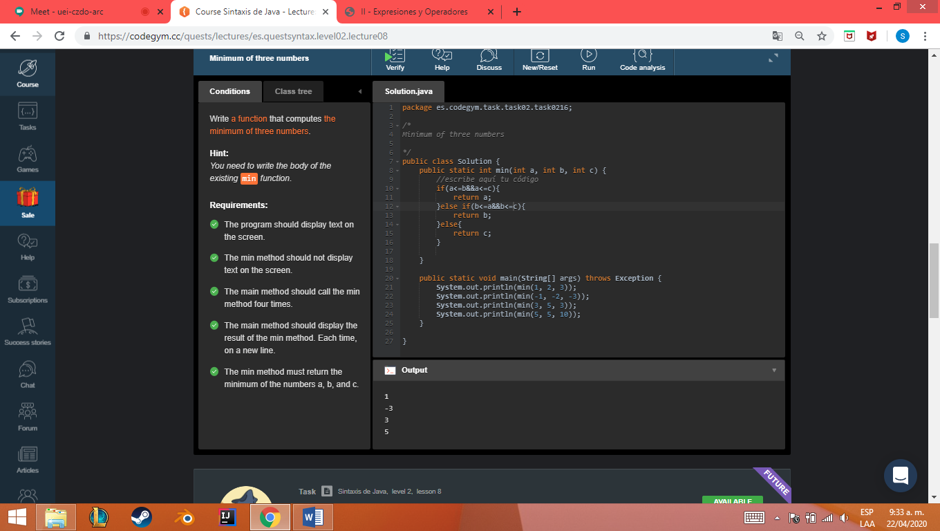

Nivel2 leccion8 ejercicio4



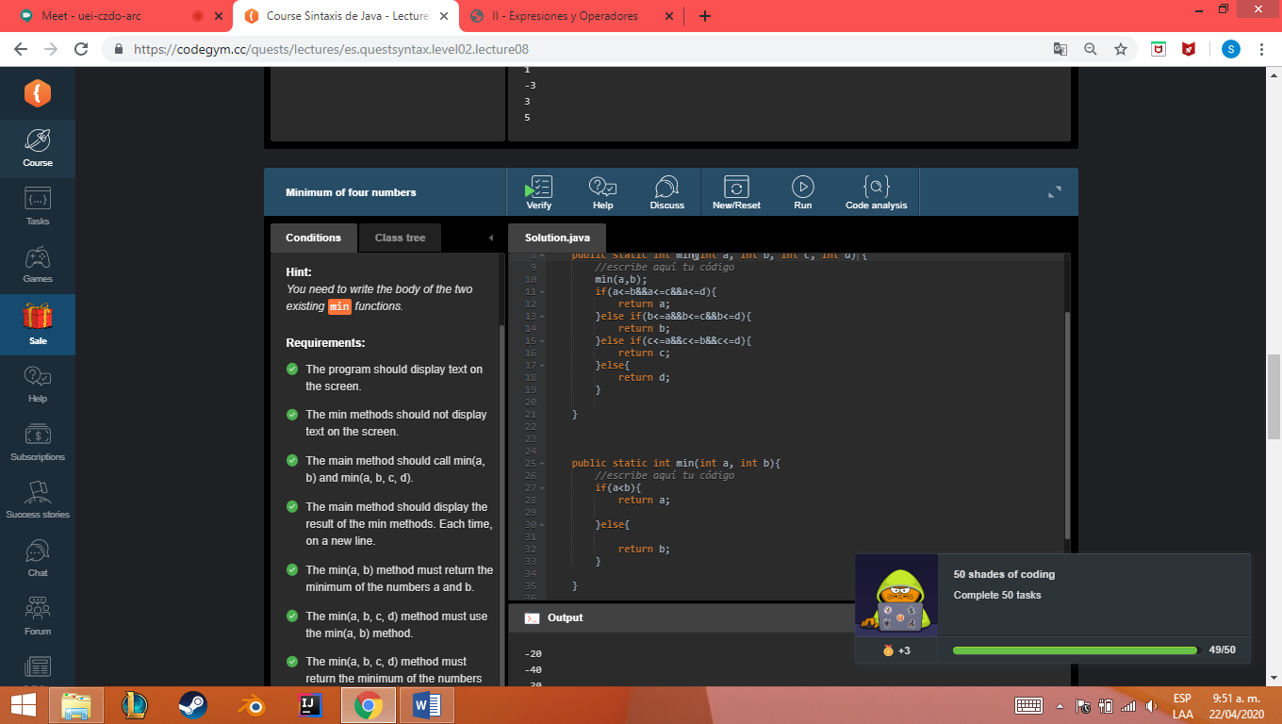

Nivel2 leccion8 ejercicio5

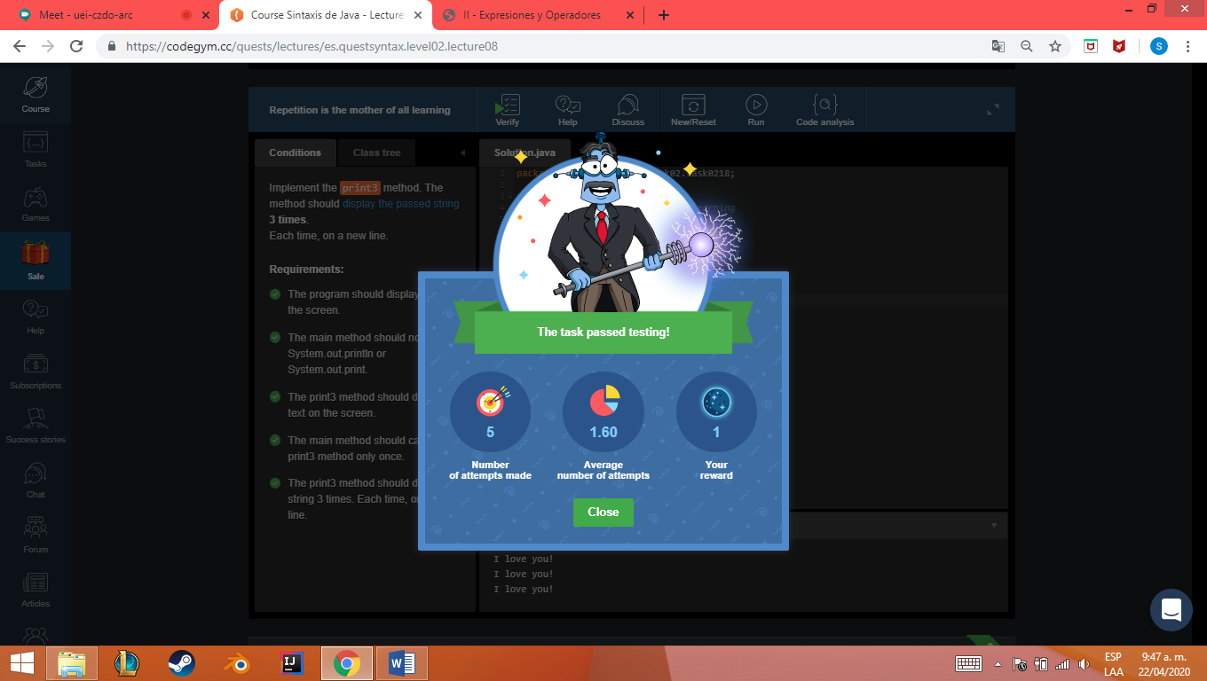

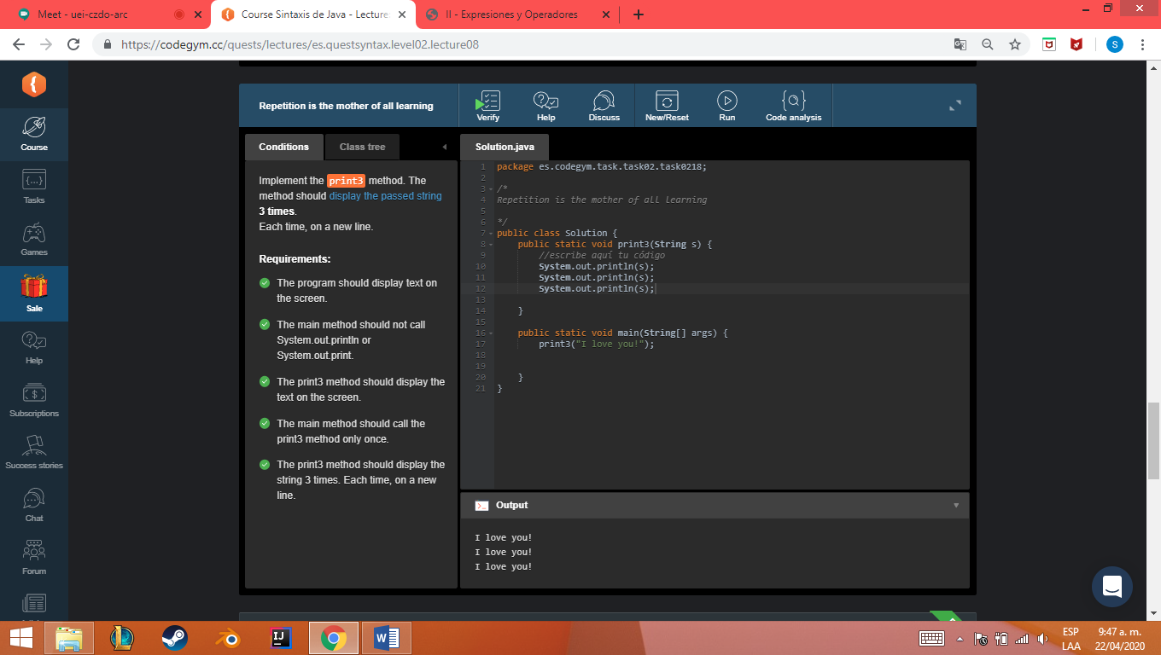

Nivel2 leccion8 ejercicio6

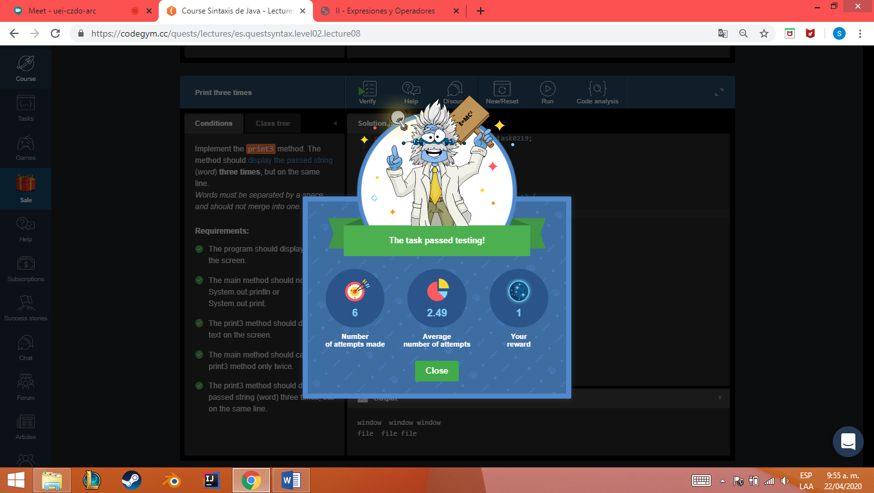

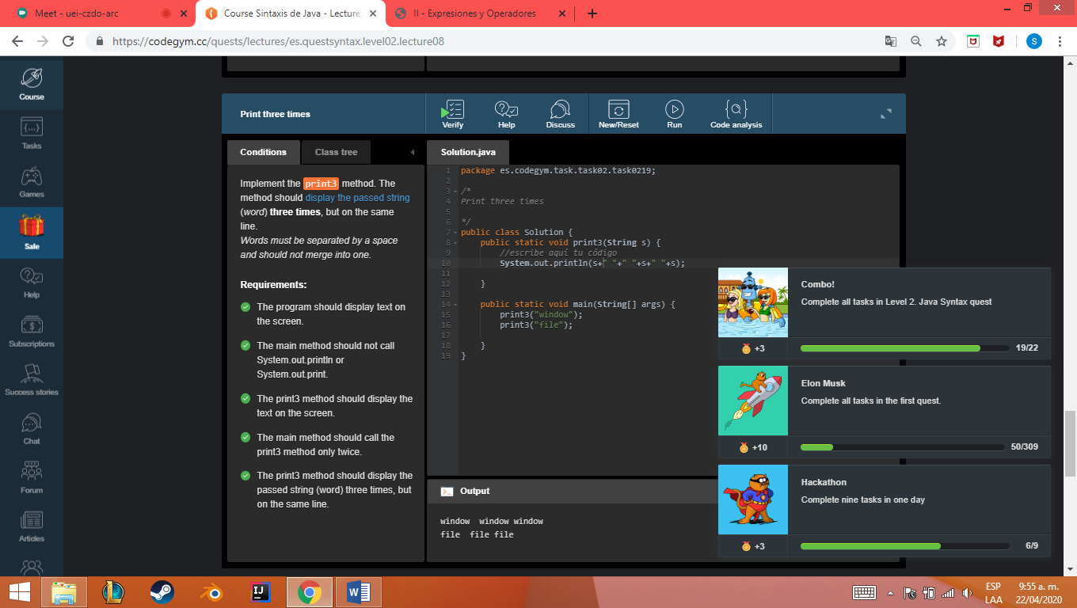

**Achievements**



